DEDICATION

DEDICATION

DEDICATION

DEDICATION

DEDICATION

DEDICATION

DEDICATION

DEDICATION

DEDICATION

DEDICATION

DEDICATION

DEDICATION

DEDICATION

DEDICATION

DEDICATION

DEDICATION

DEDICATION

DEDICATION

DEDICATION

DEDICATION

DEDICATION

DEDICATION

DEDICATION

DEDICATION

DEDICATION

DEDICATION

DEDICATION

DEDICATION

DEDICATION

DEDICATION

DEDICATION

DEDICATION

DEDICATION

DEDICATION

DEDICATION

DEDICATION

DEDICATION

DEDICATION

DEDICATION

DEDICATION

DEDICATION

DEDICATION

DEDICATION

DEDICATION

DEDICATION

DEDICATION

DEDICATION

DEDICATION

DEDICATION

DEDICATION

DEDICATION

DEDICATION

DEDICATION

DEDICATION

DEDICATION

DEDICATION

DEDICATION

DEDICATION

DEDICATION

DEDICATION

DEDICATION

DEDICATION

DEDICATION

DEDICATION

DEDICATION

DEDICATION

DEDICATION

DEDICATION

DEDICATION

DEDICATION

DEDICATION

DEDICATION

DEDICATION

DEDICATION

DEDICATION

DEDICATION

DEDICATION

DEDICATION

DEDICATION

DEDICATION

DEDICATION

DEDICATION

DEDICATION

DEDICATION

DEDICATION

DEDICATION

DEDICATION

DEDICATION

DEDICATION

DEDICATION

DEDICATION

DEDICATION

DEDICATION

DEDICATION

DEDICATION

DEDICATION

DEDICATION

DEDICATION

DEDICATION

DEDICATION

DEDICATION

DEDICATION

DEDICATION

DEDICATION

DEDICATION

DEDICATION

DEDICATION

DEDICATION

DEDICATION

DEDICATION

DEDICATION

DEDICATION

DEDICATION

DEDICATION

DEDICATION

DEDICATION

DEDICATION

DEDICATION

DEDICATION

DEDICATION

DEDICATION

DEDICATION

DEDICATION

DEDICATION

DEDICATION

DEDICATION

DEDICATION

DEDICATION

We dedicate this Work to the ELONG’S FAMILY, for their love, support and their unconditional
sacrifices for my academic success.

We dedicate this Work to the ELONG’S FAMILY, for their love, support and their unconditional
sacrifices for my academic success.

We dedicate this Work to the ELONG’S FAMILY, for their love, support and their unconditional
sacrifices for my academic success.

We dedicate this Work to the ELONG’S FAMILY, for their love, support and their unconditional
sacrifices for my academic success.

We dedicate this Work to the ELONG’S FAMILY, for their love, support and their unconditional
sacrifices for my academic success.

We dedicate this Work to the ELONG’S FAMILY, for their love, support and their unconditional
sacrifices for my academic success.

We dedicate this Work to the ELONG’S FAMILY, for their love, support and their unconditional
sacrifices for my academic success.

We dedicate this Work to the ELONG’S FAMILY, for their love, support and their unconditional
sacrifices for my academic success.

We dedicate this Work to the ELONG’S FAMILY, for their love, support and their unconditional
sacrifices for my academic success.

We dedicate this Work to the ELONG’S FAMILY, for their love, support and their unconditional
sacrifices for my academic success.

We dedicate this Work to the ELONG’S FAMILY, for their love, support and their unconditional
sacrifices for my academic success.

We dedicate this Work to the ELONG’S FAMILY, for their love, support and their unconditional
sacrifices for my academic success.

We dedicate this Work to the ELONG’S FAMILY, for their love, support and their unconditional
sacrifices for my academic success.

We dedicate this Work to the ELONG’S FAMILY, for their love, support and their unconditional
sacrifices for my academic success.

We dedicate this Work to the ELONG’S FAMILY, for their love, support and their unconditional
sacrifices for my academic success.

We dedicate this Work to the ELONG’S FAMILY, for their love, support and their unconditional
sacrifices for my academic success.

We dedicate this Work to the ELONG’S FAMILY, for their love, support and their unconditional
sacrifices for my academic success.

We dedicate this Work to the ELONG’S FAMILY, for their love, support and their unconditional
sacrifices for my academic success.

We dedicate this Work to the ELONG’S FAMILY, for their love, support and their unconditional
sacrifices for my academic success.

We dedicate this Work to the ELONG’S FAMILY, for their love, support and their unconditional
sacrifices for my academic success.

We dedicate this Work to the ELONG’S FAMILY, for their love, support and their unconditional
sacrifices for my academic success.

We dedicate this Work to the ELONG’S FAMILY, for their love, support and their unconditional
sacrifices for my academic success.

We dedicate this Work to the ELONG’S FAMILY, for their love, support and their unconditional
sacrifices for my academic success.

We dedicate this Work to the ELONG’S FAMILY, for their love, support and their unconditional
sacrifices for my academic success.

We dedicate this Work to the ELONG’S FAMILY, for their love, support and their unconditional
sacrifices for my academic success.

We dedicate this Work to the ELONG’S FAMILY, for their love, support and their unconditional
sacrifices for my academic success.

We dedicate this Work to the ELONG’S FAMILY, for their love, support and their unconditional
sacrifices for my academic success.

We dedicate this Work to the ELONG’S FAMILY, for their love, support and their unconditional
sacrifices for my academic success.

We dedicate this Work to the ELONG’S FAMILY, for their love, support and their unconditional
sacrifices for my academic success.

We dedicate this Work to the ELONG’S FAMILY, for their love, support and their unconditional
sacrifices for my academic success.

We dedicate this Work to the ELONG’S FAMILY, for their love, support and their unconditional
sacrifices for my academic success.

We dedicate this Work to the ELONG’S FAMILY, for their love, support and their unconditional
sacrifices for my academic success.

We dedicate this Work to the ELONG’S FAMILY, for their love, support and their unconditional
sacrifices for my academic success.

We dedicate this Work to the ELONG’S FAMILY, for their love, support and their unconditional
sacrifices for my academic success.

We dedicate this Work to the ELONG’S FAMILY, for their love, support and their unconditional
sacrifices for my academic success.

We dedicate this Work to the ELONG’S FAMILY, for their love, support and their unconditional
sacrifices for my academic success.

We dedicate this Work to the ELONG’S FAMILY, for their love, support and their unconditional
sacrifices for my academic success.

We dedicate this Work to the ELONG’S FAMILY, for their love, support and their unconditional
sacrifices for my academic success.

We dedicate this Work to the ELONG’S FAMILY, for their love, support and their unconditional
sacrifices for my academic success.

We dedicate this Work to the ELONG’S FAMILY, for their love, support and their unconditional
sacrifices for my academic success.

We dedicate this Work to the ELONG’S FAMILY, for their love, support and their unconditional
sacrifices for my academic success.

We dedicate this Work to the ELONG’S FAMILY, for their love, support and their unconditional
sacrifices for my academic success.

We dedicate this Work to the ELONG’S FAMILY, for their love, support and their unconditional
sacrifices for my academic success.

We dedicate this Work to the ELONG’S FAMILY, for their love, support and their unconditional
sacrifices for my academic success.

We dedicate this Work to the ELONG’S FAMILY, for their love, support and their unconditional
sacrifices for my academic success.

We dedicate this Work to the ELONG’S FAMILY, for their love, support and their unconditional
sacrifices for my academic success.

We dedicate this Work to the ELONG’S FAMILY, for their love, support and their unconditional
sacrifices for my academic success.

We dedicate this Work to the ELONG’S FAMILY, for their love, support and their unconditional
sacrifices for my academic success.

We dedicate this Work to the ELONG’S FAMILY, for their love, support and their unconditional
sacrifices for my academic success.

We dedicate this Work to the ELONG’S FAMILY, for their love, support and their unconditional
sacrifices for my academic success.

We dedicate this Work to the ELONG’S FAMILY, for their love, support and their unconditional
sacrifices for my academic success.

We dedicate this Work to the ELONG’S FAMILY, for their love, support and their unconditional
sacrifices for my academic success.

We dedicate this Work to the ELONG’S FAMILY, for their love, support and their unconditional
sacrifices for my academic success.

We dedicate this Work to the ELONG’S FAMILY, for their love, support and their unconditional
sacrifices for my academic success.

We dedicate this Work to the ELONG’S FAMILY, for their love, support and their unconditional
sacrifices for my academic success.

We dedicate this Work to the ELONG’S FAMILY, for their love, support and their unconditional
sacrifices for my academic success.

We dedicate this Work to the ELONG’S FAMILY, for their love, support and their unconditional
sacrifices for my academic success.

We dedicate this Work to the ELONG’S FAMILY, for their love, support and their unconditional
sacrifices for my academic success.

We dedicate this Work to the ELONG’S FAMILY, for their love, support and their unconditional
sacrifices for my academic success.

We dedicate this Work to the ELONG’S FAMILY, for their love, support and their unconditional
sacrifices for my academic success.

We dedicate this Work to the ELONG’S FAMILY, for their love, support and their unconditional
sacrifices for my academic success.

We dedicate this Work to the ELONG’S FAMILY, for their love, support and their unconditional
sacrifices for my academic success.

We dedicate this Work to the ELONG’S FAMILY, for their love, support and their unconditional
sacrifices for my academic success.

We dedicate this Work to the ELONG’S FAMILY, for their love, support and their unconditional
sacrifices for my academic success.

We dedicate this Work to the ELONG’S FAMILY, for their love, support and their unconditional
sacrifices for my academic success.

We dedicate this Work to the ELONG’S FAMILY, for their love, support and their unconditional
sacrifices for my academic success.

We dedicate this Work to the ELONG’S FAMILY, for their love, support and their unconditional
sacrifices for my academic success.

We dedicate this Work to the ELONG’S FAMILY, for their love, support and their unconditional
sacrifices for my academic success.

We dedicate this Work to the ELONG’S FAMILY, for their love, support and their unconditional
sacrifices for my academic success.

We dedicate this Work to the ELONG’S FAMILY, for their love, support and their unconditional
sacrifices for my academic success.

We dedicate this Work to the ELONG’S FAMILY, for their love, support and their unconditional
sacrifices for my academic success.

We dedicate this Work to the ELONG’S FAMILY, for their love, support and their unconditional
sacrifices for my academic success.

We dedicate this Work to the ELONG’S FAMILY, for their love, support and their unconditional
sacrifices for my academic success.

We dedicate this Work to the ELONG’S FAMILY, for their love, support and their unconditional
sacrifices for my academic success.

We dedicate this Work to the ELONG’S FAMILY, for their love, support and their unconditional
sacrifices for my academic success.

We dedicate this Work to the ELONG’S FAMILY, for their love, support and their unconditional
sacrifices for my academic success.

We dedicate this Work to the ELONG’S FAMILY, for their love, support and their unconditional
sacrifices for my academic success.

We dedicate this Work to the ELONG’S FAMILY, for their love, support and their unconditional
sacrifices for my academic success.

We dedicate this Work to the ELONG’S FAMILY, for their love, support and their unconditional
sacrifices for my academic success.

We dedicate this Work to the ELONG’S FAMILY, for their love, support and their unconditional
sacrifices for my academic success.

We dedicate this Work to the ELONG’S FAMILY, for their love, support and their unconditional
sacrifices for my academic success.

We dedicate this Work to the ELONG’S FAMILY, for their love, support and their unconditional
sacrifices for my academic success.

We dedicate this Work to the ELONG’S FAMILY, for their love, support and their unconditional
sacrifices for my academic success.

We dedicate this Work to the ELONG’S FAMILY, for their love, support and their unconditional
sacrifices for my academic success.

We dedicate this Work to the ELONG’S FAMILY, for their love, support and their unconditional
sacrifices for my academic success.

We dedicate this Work to the ELONG’S FAMILY, for their love, support and their unconditional
sacrifices for my academic success.

We dedicate this Work to the ELONG’S FAMILY, for their love, support and their unconditional
sacrifices for my academic success.

We dedicate this Work to the ELONG’S FAMILY, for their love, support and their unconditional
sacrifices for my academic success.

We dedicate this Work to the ELONG’S FAMILY, for their love, support and their unconditional
sacrifices for my academic success.

We dedicate this Work to the ELONG’S FAMILY, for their love, support and their unconditional
sacrifices for my academic success.

We dedicate this Work to the ELONG’S FAMILY, for their love, support and their unconditional
sacrifices for my academic success.

We dedicate this Work to the ELONG’S FAMILY, for their love, support and their unconditional
sacrifices for my academic success.

We dedicate this Work to the ELONG’S FAMILY, for their love, support and their unconditional
sacrifices for my academic success.

We dedicate this Work to the ELONG’S FAMILY, for their love, support and their unconditional
sacrifices for my academic success.

We dedicate this Work to the ELONG’S FAMILY, for their love, support and their unconditional
sacrifices for my academic success.

We dedicate this Work to the ELONG’S FAMILY, for their love, support and their unconditional
sacrifices for my academic success.

We dedicate this Work to the ELONG’S FAMILY, for their love, support and their unconditional
sacrifices for my academic success.

We dedicate this Work to the ELONG’S FAMILY, for their love, support and their unconditional
sacrifices for my academic success.

We dedicate this Work to the ELONG’S FAMILY, for their love, support and their unconditional
sacrifices for my academic success.

We dedicate this Work to the ELONG’S FAMILY, for their love, support and their unconditional
sacrifices for my academic success.

We dedicate this Work to the ELONG’S FAMILY, for their love, support and their unconditional
sacrifices for my academic success.

We dedicate this Work to the ELONG’S FAMILY, for their love, support and their unconditional
sacrifices for my academic success.

We dedicate this Work to the ELONG’S FAMILY, for their love, support and their unconditional
sacrifices for my academic success.

We dedicate this Work to the ELONG’S FAMILY, for their love, support and their unconditional
sacrifices for my academic success.

We dedicate this Work to the ELONG’S FAMILY, for their love, support and their unconditional
sacrifices for my academic success.

We dedicate this Work to the ELONG’S FAMILY, for their love, support and their unconditional
sacrifices for my academic success.

We dedicate this Work to the ELONG’S FAMILY, for their love, support and their unconditional
sacrifices for my academic success.

We dedicate this Work to the ELONG’S FAMILY, for their love, support and their unconditional
sacrifices for my academic success.

We dedicate this Work to the ELONG’S FAMILY, for their love, support and their unconditional
sacrifices for my academic success.

We dedicate this Work to the ELONG’S FAMILY, for their love, support and their unconditional
sacrifices for my academic success.

We dedicate this Work to the ELONG’S FAMILY, for their love, support and their unconditional
sacrifices for my academic success.

We dedicate this Work to the ELONG’S FAMILY, for their love, support and their unconditional
sacrifices for my academic success.

We dedicate this Work to the ELONG’S FAMILY, for their love, support and their unconditional
sacrifices for my academic success.

We dedicate this Work to the ELONG’S FAMILY, for their love, support and their unconditional
sacrifices for my academic success.

We dedicate this Work to the ELONG’S FAMILY, for their love, support and their unconditional
sacrifices for my academic success.

We dedicate this Work to the ELONG’S FAMILY, for their love, support and their unconditional
sacrifices for my academic success.

We dedicate this Work to the ELONG’S FAMILY, for their love, support and their unconditional
sacrifices for my academic success.

We dedicate this Work to the ELONG’S FAMILY, for their love, support and their unconditional
sacrifices for my academic success.

We dedicate this Work to the ELONG’S FAMILY, for their love, support and their unconditional
sacrifices for my academic success.

We dedicate this Work to the ELONG’S FAMILY, for their love, support and their unconditional
sacrifices for my academic success.

We dedicate this Work to the ELONG’S FAMILY, for their love, support and their unconditional
sacrifices for my academic success.

We dedicate this Work to the ELONG’S FAMILY, for their love, support and their unconditional
sacrifices for my academic success.

We dedicate this Work to the ELONG’S FAMILY, for their love, support and their unconditional
sacrifices for my academic success.

We dedicate this Work to the ELONG’S FAMILY, for their love, support and their unconditional
sacrifices for my academic success.

We dedicate this Work to the ELONG’S FAMILY, for their love, support and their unconditional
sacrifices for my academic success.

We dedicate this Work to the ELONG’S FAMILY, for their love, support and their unconditional
sacrifices for my academic success.

We dedicate this Work to the ELONG’S FAMILY, for their love, support and their unconditional
sacrifices for my academic success.

We dedicate this Work to the ELONG’S FAMILY, for their love, support and their unconditional
sacrifices for my academic success.

ACKNOWLEDGEMENTS
Drafting this document would not have been possible without the contributions of several individuals who dedicated their time and efforts to ensure its completion. Our heartfelt gratitude goes to the following people:
- The Resident Representative of AICS Cameroon, Mr. Armand Claude ABANDA, for his unwavering support, encouraging words, and valuable advice on how to approach various situations.
- The General Manager of SOS-Telecoms MR. WARGUILI JOSUE and his staff for trusting us with the opportunity to serve as interns in their prestigious enterprise. Your support and guidance have been invaluable to our learning experience.
- To the General Manager of ABC LOGISTICS MR. ELONGBIL NGANDO for entrusting us with this project.
- Our professional supervisor, Mr. LUDOVIC for his moral support, advice and professional expertise he shared with us.
- Our academic supervisor, Mr. NDENGE for his moral support, efforts, and invaluable advice throughout the academic year.
- Our academic teachers, Mr. AGBOR ANDERSON, MR NGUH Prince, MR. MESSIO and Mrs. TCHOUTOUO Isabelle, for their guidance and assistance in the realization of this document.
- To all my teachers at AICS Cameroon, for the knowledge they imparted, which has been essential in my journey.
- To my brothers and sister, for their unwavering love and support.
- To the countless contributors of the open-source programming community, for their invaluable resources that helped me learn essential skills and troubleshoot issues.
- A special thanks to my classmates KAMSONG Gaston and KAMSU Marcelle and all the other classmates that contributed in one way or the other in the realization of this project.

LIST OF ABBREVATIONS
- 2TUP: Two Track Unified Process
- AICS: African Institute of Computer Sciences
- API: Application Programming Interface
- CSS: Cascading Style Sheets
- DBMS: Database Management System
- HTML: Hypertext Markup Language
- JS: JavaScript
- SQL: Structured Query Language
- UML: Unified Modelling Language

ABSTRACT
The study of the theme “CONCEPTION AND REALIZATION OF AN AI-POWERED CAR MARKETPLACE PLATFORM” aims to develop a centralized, intelligent, and secure platform to facilitate buying, selling, and managing vehicles while providing AI-driven features to enhance user experience. In a context where vehicle trading in Cameroon faces challenges such as fragmented listings, inefficient search, and lack of pricing guidance, this system seeks to unify car marketplace operations, streamline transactions, and provide personalized recommendations for buyers and sellers.
The core objectives are to simplify listing management, ensure secure and reliable interactions, and leverage AI to assist users with tasks such as background removal of car images, price prediction based on vehicle specifications, and smart recommendations tailored to user preferences. The platform integrates Arcjet for security, offering protection against bots, abuse, and rate-limit violations, and uses Supabase (PostgreSQL-based) with Prisma ORM for reliable data storage and management. AI modules process car details, market data, and user behavior to provide intelligent search results and personalized car suggestions.
By adopting a modern Next.js + React + Tailwind CSS architecture, the platform offers scalability, accessibility, and a responsive user interface suitable for both web and mobile environments. Its innovative aspect lies in combining AI-powered features, secure cloud-based operations, and a user-friendly marketplace into a unified and intelligent car trading ecosystem.
Keywords:
- Car Marketplace
- Artificial Intelligence
- Price Prediction
- Security (Arcjet)
- Supabase

RÉSUMÉ
L’étude sur le thème « CONCEPTION ET RÉALISATION D'UNE PLATEFORME DE MARCHÉ AUTOMOBILE INTELLIGENTE » se à développer une plateforme centralisée, intelligente et sécurisée permettant l’achat, la vente et la gestion de véhicules, tout en offrant des fonctionnalités basées sur l’intelligence artificielle pour améliorer l’expérience utilisateur. Dans un contexte où le commerce automobile au Cameroun fait face à des défis tels que des annonces fragmentées, des recherches inefficaces et un manque d’orientation sur les prix, ce système cherche à unifier les opérations du marché automobile, à simplifier les transactions et à fournir des recommandations personnalisées aux acheteurs et aux vendeurs.
Les principaux objectifs sont de faciliter la gestion des annonces, d’assurer des interactions sécurisées et fiables, et d’exploiter l’IA pour assister les utilisateurs dans des tâches telles que le retrait automatique de l’arrière-plan des images de voitures, la prédiction de prix basée sur les spécifications des véhicules, et des recommandations intelligentes adaptées aux préférences des utilisateurs. La plateforme intègre Arcjet pour la sécurité, offrant une protection contre les bots, les abus et les violations de limitation de requêtes, et utilise Supabase (basé sur PostgreSQL) avec Prisma ORM pour un stockage et une gestion fiable des données. Les modules d’IA traitent les détails des voitures, les données du marché et le comportement des utilisateurs afin de fournir des résultats de recherche intelligents et des suggestions personnalisées.
En adoptant une architecture moderne Next.js + React + Tailwind CSS, la plateforme offre évolutivité, accessibilité et une interface utilisateur réactive adaptée aux environnements web et mobile. Son aspect innovant réside dans la combinaison de fonctionnalités basées sur l’IA, d’opérations sécurisées dans le cloud et d’un marché convivial en une solution unifiée et intelligente pour le commerce automobile.

Mots-clés :
- Marché Automobile
- Intelligence Artificielle
- Prédiction de Prix
- Sécurité (Arcjet)
- Supabase

SUMMARY

DEDICATION i
ACKNOWLEDGEMENTS ii
ABSTRACT iv
RESUME Error! Bookmark not defined.
SUMMARY vi
LIST OF FIGURES vii
LIST OF TABLES ix
GENERAL INTRODUCTION Error! Bookmark not defined.
PART ONE: INSERTION PHASE 3
PART TWO: TECHNICAL PHASE Error! Bookmark not defined.
BOOK ONE: EXISTING Error! Bookmark not defined.
BOOK TWO: SPECIFICATION PHASE 25
BOOK THREE: Error! Bookmark not defined.
ANALYSIS PHASE Error! Bookmark not defined.
BOOK FOUR: CONCEPTION PHASE Error! Bookmark not defined.
BOOK FIVE: REALIZATION PHASE Error! Bookmark not defined.
BOOK SIX: TEST OF FUNTIONALITIES 98
BOOK SEVEN: USER GUIDE Error! Bookmark not defined.
GENERAL CONCLUSION 113
BIBLIOGRAPHY ix
WEBOGRAPHY xii
ANNEX xiii
CONTENT xiv

LIST OF FIGURES

LIST OF TABLES

Table 1:Hard ware resources 10
Table2:Software resources of SOS-Telecoms (source: mercurial 2024) 10
Table 3:Criticism of the existing system 17
Table 4 Hardware Resources of the project (Source: Mercurial 2023-2024) 31
Table 5:Software resources (source: Mercurial 2023/2024) 31
Table 6:Software resources (source: Mercurial 2023/2024) 32
Table 7: Total project Estimated cost 33
Table 8: Estimation of required time for the project 34
Table 9::Project participants 36
Table 10:Use case diagram components 49
Table 11: Formalism of Textual Description 52
Table 12:authentication textual description 53
Table 13:add car textual description 54
Table 14:book test-drive textual description 55
Table 15:Component of a Sequence Diagram 57
Table 16: Component of an Activity Diagram 62
Table 17:Component of a Class diagram 72
Table 18:Components of a State Machine diagram 75
Table 19:Package Diagram Formalism 78
Table 20:Components of an Object Diagram 82
Table 21: Formalism of a component Diagram 88
Table 22: Component of a Deployment Diagram 91
Table 23: Material resources 92
Table 24: Software resources 92
Table 25:system requirements for installation 104
Table 26:system verification 106

GENERAL INTRODUCTION

In the digital era, the automotive marketplace is rapidly evolving thanks to intelligent technologies that enhance operational efficiency and user experience. However, in Cameroon, most vehicle trading still relies on manual processes or fragmented digital systems, resulting in scattered listings, inefficient search, and a lack of reliable recommendations for buyers and sellers. This environment makes it challenging to manage listings centrally, track vehicles, and effectively connect stakeholders.
To address these challenges, the project “Conception and Realization of an AI-Powered Car Marketplace Platform” was undertaken. The main objective is to develop a centralized, secure platform that unifies listing management, simplifies transactions, and provides intelligent features to enhance user experience. Key innovations include the integration of artificial intelligence for:
Price Prediction: Smart price estimation based on vehicle specifications and market trends.
Personalized Recommendations: Suggesting cars tailored to users’ preferences and browsing behavior.
Fraud Detection and Security Monitoring: AI-driven analysis combined with Arcjet security tools to detect suspicious activities, prevent fraud
Platform security is ensured through Arcjet, which protects against bots, abuse, and rate-limit violations. Data is reliably stored and managed using Supabase (PostgreSQL) with Prisma ORM, ensuring efficient and centralized management of user and vehicle information.
The platform is built with Next.js 15, React 19, and Tailwind CSS, providing a responsive and accessible user interface across web and mobile devices. The approach combines AI intelligence, enhanced security, and modern user experience to deliver a unified, reliable, and intelligent automotive marketplace.
For clarity and structure, this report is divided into eight (8) parts, each focusing on a specific aspect of the project:
1. Insertion Document: Here, we will present the company in which we spent our
internship period and the way we were welcomed in the company. At the end of this
part, we will present the theme given to us.
2. Existing System: Here, we shall present the already present system in place, that is the
one used for consultation and follow-up purposes
3. Specification Book: In this book, we specify the needs of the user taking in to
considerations the time and cost of the project.
4. Analysis Document: Here, we will present the analysis method chosen together with
the presentation of all the diagrams used for the analysis of the project.
5. Conception phase: This presents the generic and detailed conception of the project to bring out real world constituents
6. The Realisation phase: This phase will permit us to visualise the implementation
process of the solution.
7. Test of functionalities: In this phase, we shall present to you the different functionalities or modules of our application and how they work
8. The user Manual: Which will present the conditions necessary to use the application
and how to use it

PART ONE: INSERTION PHASE

Preamble
This phase presents the details of how we were integrated in the host company, the company presentation and organisation.
Content Overview

INTRODUCTION
- WELCOME AND INTEGRATION
- GENERAL PRESENTATION OF THE COMPANY
- ORGANISATION OF THE COMPANY
- HARDWARE AND SOFTWARE RESOURCES OF THE COMPANY
- BRIEF PRESENTATION OF THE PROJECT THEME
CONCLUSION

INTRODUCTION
The internship period is a time when the student gains professional experience and addresses challenges faced by the company. The insertion phase refers to this period during which the student acclimatizes to the work environment at their internship site and applies the knowledge acquired. They need to familiarize themselves with their internship supervisor, commonly known as the professional mentor, and learn to collaborate with their fellow interns. This initial transition into a professional setting can be challenging for students. Therefore, we will outline this phase as it took place for us at SOS-Telecoms.

WELCOME AND INTEGRATRION

Welcoming phase
On July 8, 2024, we embarked on our internship journey at the SOS-Telecoms offices as academic interns. We received a warm welcome and were given an insightful guided tour of the company facilities. Following this introduction, we were encouraged to feel at home and immerse ourselves in the environment. As we settled in, we focused on familiarizing ourselves with our new surroundings. The next day, which marked the official start of our internship, we engaged in discussions about key topics that would allow us to enhance our expertise. Two weeks later, our supervisor and we collaboratively developed a list of innovative themes aimed at addressing the challenges faced by Cameroonian society in particular.
Integration phase
A preliminary meeting was convened by the company director, during which key aspects of the organization were reviewed, including internal regulations, overall operations, vision, objectives, and the range of services offered. Particular emphasis was placed on expected behaviors and strict adherence to the established guidelines. Additionally, during a series of collaborative sessions with the staff, we received valuable insights and recommendations that enriched our understanding of the organizational environment. Ultimately, these exchanges provided an opportunity for meaningful discussions and constructive dialogue about our project topic.
This project was conceived for a new enterprise that SOS Telecoms intends to establish in Cameroon, known as ABC Logistics. With the close supervision of our project supervisor and the technical guidance of the computer engineer from SOS Telecoms, we successfully initiated the conception and realization of an AI-powered car marketplace platform

GENERAL PRESENTATION OF THE COMPANY

History
Founded in 2010, SOS TELECOMS is a leading company in the telecommunications, energy, tower construction, air conditioning, and other sectors.
The company currently its headquarters in N’Djamena, Republic of Chad. It also has branches in several countries, including Niger, Burkina Faso, Togo, South Sudan, and the Central African Republic, with the aim of expanding its network to bring its services as close as possible to all parts of the continent. SOS TELECOMS is a company specializing in telecommunications engineering and energy solutions.

Services
- Deployment of fiber optic
- Telecom construction sites
- Installation and configuration of all network equipment
- Installation of solar panels
- Hosting and monitoring of client devices

Geographical location

The company SOS-telecoms is located in the quarter 36 villas, nearby the Barthélemy Baganda government school Bangui, specifically on street n1.156,SOS-telecoms is located especially in the port Amont found in Bangui city center, as shown in the following figure:
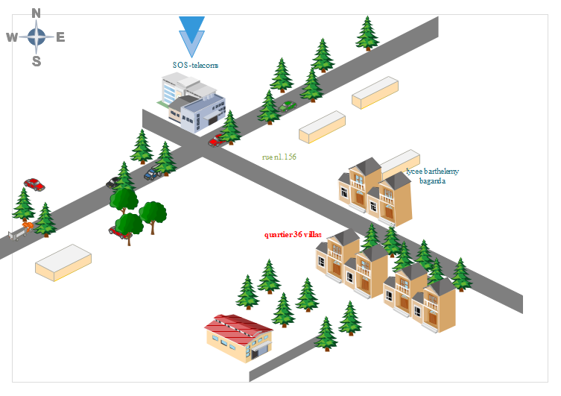

Figure 1:GEOGRAPHICAL LOCATION OF SOS-Telecoms (source: sos-telecoms)

ORGANIZATION OF THE COMPANY
General Management
General Secretariat
Technical Department
Communication & Marketing Department
External Relations Department
Training Department
Human Resources Department
Financial Department
Research & Innovation Department

Figure 2:sos-telecoms organizational chart

RESOURCES OF THE COMPANY
As an enterprise specialised in Telecommunications, SOS-Telecoms also comprises of software resources such as;

Hardware Resources
$$N^{O}$$ | Designation | Quantity | Characteristics | Observation
1 | MacBook Pro | 1 | APPLE | Good
2 | Modem | 1 | CAMTEL | Good
3 | LCD Screen | 1 | HP | Good
Table 1:Hard ware resources

Software Resources
Designation | Software
Operation system | Windows 10, Mac OS, parrot Linux
Design tools | Photoshop
Integrated development environment (IDE) | Visual studio code, Android studio
Text editor | notepad
Database management system (DBMS) | Supabase (Postgres Sql. database)
Web browser | Google chrome, Microsoft edge,brave
Document editor | Microsoft office word
Presentation | Microsoft office PowerPoint
Table2:Software resources of SOS-Telecoms (source: mercurial 2024)

CONCLUSION
At the conclusion of our insertion phase, we gained a comprehensive understanding of SOS-Telecoms, its offerings and services, and its organizational structure. This phase was rich in emotional and educational experiences, as it enabled us to integrate into a dynamic professional team. We adapted to the fast-paced work environment and became aware of the professional standards expected of us. With the necessary insights gathered about the company, we were poised to embark on the next innovative steps in our project.

PART TWO: TECHNICAL PHASE

BOOK ONE: EXISTING SYSTEM

Preamble
The existing system is a document that provides a view of the system currently in place, that is how it carries out its different activities, also it provides a deep understanding of this system associated to the various limitations, the problems that result from these and the solution we propose.
Content overview
INTRODUCTION
- DESCRIPTION OF THE EXISTING SYSTEM
- STUDY OF THE EXISTING
- CRITISISM OF THE EXISTING
- PROBLEMATIC
- PROPOSED SOLUTION
CONCLUSION

INTRODUCTION
As Engineers our role in the society is problem-solving which is targeted at making life easier for everyone and in order to bring forth a solution, we ought to ask ourselves some questions to know why the problem exist in the first place and how it is being dealt with at the time.
The existing system refers to the system put in place to carry out the work done in the field on which our theme is based. Understanding this system is a great step in solving the problems that we might identify. It’s of great importance that we take into consideration this system before proposing a suitable solution that will ameliorate or replace the current one.

BRIEF PRESENTATION OF THE PROJECT THEME
During our internship at SOS-Telecoms, we were encouraged to work on a project that would not only strengthen our technical expertise but also provide a practical solution with social and economic impact. In line with the company’s mission of enlarging their logistics company (ABC LOGISTICS), I identified an opportunity to design a platform addressing the key challenges in the Cameroonian automotive marketplace, where car trading remains largely manual and fragmented.
The proposed theme, “CONCEPTION AND REALIZATION OF AN AI-POWERED CAR MARKETPLACE PLATFORM”, led to the creation of VEHIQL a centralized and intelligent solution that simplifies car trading, ensures transparency, and improves the overall user experience. The platform integrates artificial intelligence, modern web technologies, and robust security systems to connect buyers, sellers, and dealerships more effectively.
The system is designed with the following key components:
- AI Car Search and Image Recognition allowing users to upload a car image and instantly find similar vehicles in the marketplace.
- Advanced Car Listing Management, enabling vendors to add, update, and manage car inventories, managing inventory, monitoring user test drive requests, and accessing sales analytics through an intuitive dashboard.
- User Dashboard providing clients with advanced filters, personalized recommendations, EMI calculators, and real-time test drive booking.
- Secure Authentication and Authorization powered by Clerk, with role-based access controls for different user groups.

Key innovations of the platform include:
- Smart Price Prediction based on specifications and market data
- Personalized Recommendations tailored to users’ browsing behavior and preferences.
- Arcjet Security Integration ensuring protection against bots, abuse, and rate-limit violations.
- Supabase + Prisma ORM for reliable, centralized management of vehicle and user information.
The application leverages Next.js 15, React 19, Tailwind CSS, and Shadcn UI components to deliver a responsive and modern interface, while the Gemini API powers semantic search and AI-based image recognition. By combining artificial intelligence, enhanced security, and user-focused design, this VEHIQL contributes to modernizing the automotive sector in Cameroon, creating a reliable and innovative marketplace that bridges the gap between traditional practices and digital transformation.

DESCRIPTION OF THE EXISTING SYSTEM
The current process of buying and selling cars largely relies on traditional, manual methods that are often inefficient and fragmented. Car buyers and sellers face several challenges due to the lack of integrated digital tools tailored to streamline these processes. Below is a detailed overview of how the existing system operates:
The typical process was as follows;
Physical visits and word-of-mouth: Buyers often had to visit multiple car dealers or private vendors to find vehicles, relying on personal networks or advertisements in newspapers.
- Manual negotiations: Prices were negotiated directly between the buyer and seller without access to market-based pricing information, leading to inconsistent and sometimes unfair pricing.
- Limited vehicle information: Buyers had limited access to detailed car specifications, histories, or condition reports, making it difficult to make informed decisions.
- Time-consuming processes: Transactions required in-person meetings, paper-based agreements, and manual verification of vehicle ownership or documents.

LIMITS OF THE EXISTING SYSTEM
Table 3:Criticism of the existing system
Problems | Consequences | Proposed Solutions
Manual and time-consuming process of listing and finding cars | Buyers spend excessive time searching for vehicles; sellers struggle to reach potential buyers | Automate car listings, search, and management; centralize all data in a digital platform
Lack of price transparency and market guidance | Buyers may overpay, and sellers may undervalue their cars | Implement AI-based price prediction.
Limited access to vehicle information and history | Buyers make poorly informed decisions; higher risk of fraud | Provide detailed car information, including specifications, images, history reports, and AI-powered image enhancement
Difficulty reaching buyers or sellers in remote areas | Transactions are delayed or missed; market access is uneven | Enable online transactions and smart matching between buyers and the seller regardless of location

PROBLEMATIC
With the description of the current car trading process and its limitations clearly established, we can now formulate the central problem that our project seeks to address:
“HOW CAN WE INTEGRATE INTELLIGENT DIGITAL TOOLS INTO THE CAR TRADING PROCESS TO ADDRESS INEFFICIENCIES, FACILITATE SECURE AND RELIABLE?”
This key question guided our development process and was answered through a set of innovative and efficient digital solutions implemented in the VEHIQL platform. These solutions aim to eliminate the delays, misunderstandings, and risks present in traditional car trading—making buying and selling smarter, faster, safer, and more user-friendly through AI-powered tools and enhanced security features.

PROPOSED SOLUTION
Centralized Car Listing Management
Develop a digital system where sellers can create and manage their vehicle listings, upload car images, specify specifications, and store transaction history. This reduces the inefficiencies of manual listing methods and ensures easy access to updated car information for both sellers and buyers.
AI-Powered Price Prediction and Recommendations
Implement an AI module that provides smart price estimations based on vehicle specifications and current market trends, as well as personalized car suggestions for buyers. This promotes informed decision-making and reduces the risk of overpricing or undervaluing vehicles.
Real-Time Test Drive and Appointment Scheduling
Build an integrated scheduling tool that allows buyers to book test drives or consultation appointments with sellers and dealerships. The system synchronizes with dashboards and sends automated reminders, improving time management and reducing missed opportunities.
Enhanced Security with Arcjet
Integrate Arcjet security to protect the platform against bots, abuse, and fraudulent transactions, ensuring safe interactions and trustworthiness for all users.
Centralized Database Management with Supabase + Prisma
Use a reliable, centralized database for vehicle and user information, ensuring consistency, integrity, and accessibility across the platform.

DELIMITATIONS OF THE FIELD OF STUDY
Visitor (Unauthenticated User) Capabilities:
Register on the Platform: Visitors can fill out a registration form to become a client and access additional features.
Search for Cars: Use manual filters (make, model, price, body type, etc.) or upload a car image for AI-powered search.
Browse Inventory: View all available cars in the marketplace without logging in.
Client (Authenticated User) Capabilities:
- View Car Details: Access specifications, photos, and related information for a selected car.
- Car Actions from Details Page:
- Save a car to favorites.
- Share a car via social platforms or direct links.
- Perform EMI calculations to estimate monthly payments.
- Book a test drive with real-time dealership availability
- Request additional information from the dealership or admin.
- Manage Saved Cars: Access and organize favorited cars.
- Manage Profile: Update personal information, contact details, and account settings.
Vendor capabilities:
- Dashboard Access: View analytics and overall inventory.
- Car Management:
- Feature cars on the homepage.
- Add cars manually or via AI-assisted image upload for automatic data extraction.
- Change car status (available, sold, pending, etc.).
- Delete cars from the system.
- View and search the complete inventory.

- Test Drive Management:
- Search for test drive bookings.
- Confirm, complete, or cancel test drive requests.
- Secure Logout: Safely disconnect from the platform to protect sensitive data.

Administrator (Admin) Capabilities:
- Secure Authentication: Log in with admin credentials to access administrative functions.
- Manage users, including clients and vendors
- Dashboard Access: View analytics and overall system statistics.

CONCLUSION
To conclude this section, we conducted a study of the traditional car trading system by evaluating common practices and their limitations. Based on this analysis, we identified the challenges users face, such as fragmented listings, inefficient communication between buyers and sellers, delayed transactions, and the difficulty of determining fair prices. We then proposed a modern digital solution in the form of the VEHIQL platform, an AI-powered car marketplace, to address these issues. This step was crucial for understanding the weaknesses of the current system so we could design a solution that streamlines car trading, enhances security, and provides intelligent recommendations to improve the buying and selling experience for all users.

BOOK TWO: SPECIFICATION PHASE

Content

INTRODUCTION
- CONTEXT AND JUSTIFICATION
- OBJECTIVES OF THE PROJECT
- EXPRESSIONS OF NEEDS
- TARGET POPULATION AND BENEFICIARIES
- ESTIMATED COST OF THE PROJECT
- ESTIMATED OF TIME REQUIRED
- CONSTRAINT
- LIST OF PARTICIPANTS AND DELIVERABLES
CONCLUSION

INTRODUCTION
The specification book of our reports helps us provide details about our theme, to improve our understanding of it and increase the likelihood of it succeeding. To delimitate the scope of our project, we will specify the context of our theme. From the context, we will list the problems we have identified in our context and that we have decided to address throughout the project. After presenting our solution, we will talk about the objective we have set for ourselves for the project. Also, we will explore the needs to which our system will respond both at the functional and non-functional level. We will then look at the estimated financial requirements for our project, and establish a plan we will follow to complete our project on time. From here we will discuss what is expected of us by the end of the project under the project deliverables

CONTEXT AND JUSTIFICATION

Context
In the automotive marketplace, buying and selling cars has traditionally been handled through manual processes, such as visiting dealerships, relying on word-of-mouth, or searching through classified ads. These methods are often time-consuming, inefficient, and insecure, creating difficulties for buyers to find suitable vehicles and for sellers to reach potential customers effectively.

To address these challenges, the project “Conception and Realization of an AI-Powered Car Marketplace Platform (VEHIQL)” was initiated in collaboration with ABC Logistics, a company operating under SOS-Telecoms. The platform is designed to provide a modern online solution that enables buyers and sellers to interact efficiently, securely, and intelligently. It centralizes car listings, enhances communication, and integrates AI-powered tools to make the process of buying and selling vehicles faster, safer, and more transparent.

Justification
The need for a digital car marketplace arises from several shortcomings in traditional car trading methods:
Lack of transparency: Buyers often face incomplete or inaccurate information about vehicles and pricing.
Limited access to vehicle history: It is difficult to verify the condition, ownership, or accident history of cars.
Inefficient communication: Buyers and sellers frequently experience delays or misunderstandings during negotiations.
Security risks: Manual transactions expose participants to fraud and payment vulnerabilities.

By leveraging modern web technologies, a centralized cloud database (Supabase + Prisma ORM), and AI modules for price prediction, personalized recommendations, and image-based search, VEHIQL addresses these challenges. The platform ensures that users can find cars matching their preferences, make informed decisions, and conduct transactions securely—all from a single digital platform accessible from anywhere.

OBJECTIVES OF THE PROJECT

General Objective
The general objective is to develop VEHIQL a web-based AI-Powered Car Marketplace Platform that facilitates smooth, secure, and intelligent interactions between car buyers and sellers, while providing tools to make informed decisions and manage listings efficiently.

Specific Objectives
- Enable centralized management of car listings:
- Sellers can upload, edit, and manage vehicles easily, while buyers can access all available listings in one place.
- Provide AI-powered price predictions and recommendations:
- Help buyers and sellers make informed decisions with fair pricing and personalized suggestions.
- Ensure secure transactions:
- Integrate and protection tools (e.g., Arcjet) to reduce fraud and risks.
- Improve accessibility and convenience:
- Enable users to buy or sell cars from anywhere, reducing the need for physical visits.

EXPRESSION OF NEEDS

Functional Needs
Functional needs describe the specific capabilities and features that the VEHIQL AI Car Marketplace Platform must provide to meet the requirements of its primary users — visitors, clients, vendors, and administrator. These functionalities are essential to ensure a smooth, intelligent, and secure car trading experience.

1. User Registration and Authentication
- The platform must support secure account creation and login for different user roles:
- Visitors: Can register on the platform by filling out a registration form to become a client.
- Clients (Authenticated Users): Can log in to access personalized features such as saved cars, test drive booking, and EMI calculations.
- Administrator (Admin): Authenticate securely to manage users and system settings.
- Vendors (Authenticated Users): Authenticate securely to access the dashboard, manage inventory.
2. Profile and Account Management
- Clients: Should be able to update and manage personal details.
- Administrator: Can monitor and modify user profiles (clients or vendors) when necessary for compliance or platform management.
3. Car Listing and Discover
- Visitors: Can browse all available cars without authentication and search for vehicles using filters (make, model, price, body type, etc.) or upload an image through the AI-powered search engine.
- Clients: Can view detailed car specifications, photos, and related information.
- Vendors: Can add new cars (manually or via AI image upload with auto data extraction), feature cars on the homepage, change car status (available, sold, pending), delete cars, and search/view inventory.
4. Client-Side Actions
- authenticated clients can:
- Save a car (add to favorites).
- Share a car via social media or links.
- Perform EMI calculations to estimate monthly payments.
- Book a test drive with real-time dealership availability.
- Request additional information from the dealership or admin.
- Access and manage a list of saved/favorited cars.

5. Test Drive Management
- Clients: Can schedule and manage test drives according to dealership availability.
- Vendors: Can search for test drive bookings, confirm, complete, or cancel requests.
6. Reporting and Analytics
- Vendors: Can access dashboard analytics, inventory statistics, and user activity reports to make informed operational and business decisions.

Non-Functional Needs
Non-functional needs refer to the system's overall performance, usability, and operational requirements. These address how the system should perform rather than what it should do.
- Maintainability and Scalability: The system must be capable of handling a growing number of users and increased data without performance degradation.
- Security: VEHIQL must ensure robust security mechanisms to protect sensitive data such as personal details, vehicle details. All data should be encrypted in transit and at rest. Role-based access control and multi-factor authentication should be implemented to prevent unauthorized access.
- Reliability: The system must be reliable and available at all times, with minimal downtime. A reliable backup system should be in place to prevent data loss.
- Performance: The platform should have fast loading times, quick response to user inputs, and efficient data processing to ensure a smooth user experience.
- Cross-Platform Compatibility: The platform should be compatible with various devices and operating systems, including web browsers, Android, and iOS devices.
- User-Friendly Interface: The UI/UX should be intuitive and clean, catering to users with different technical proficiencies. Clear navigation, consistent styling, and meaningful feedback (e.g., success/failure messages) should help users easily complete tasks like applying for jobs, posting listings, or updating profiles.
- Accessibility: The platform should be accessible to all users, including those with disabilities, by following web accessibility standards (e.g., WCAG 2.1).
- Maintainability: The codebase should be well-documented and modular, allowing for easy updates, bug fixes, and feature additions.

TARGET POPULATION AND BENEFICIARIES

1. Clients
Primary Users:
Individuals or businesses looking to purchase vehicles, including first-time buyers, car enthusiasts, and dealerships seeking inventory.

Key Benefits:
- Access to a wide range of verified car listings with detailed specifications, photos, and history.
- Receive AI-powered personalized recommendations based on browsing behavior, preferences, and past searches.
- Ability to save favorite cars, share listings, and perform EMI calculations for financing options.
- Book real-time test drives with sellers and request additional information directly through the platform.
- Streamlined communication with sellers for secure and transparent transactions.

2. Vendors
Primary Users:
Individual car owners, dealerships, and resellers who list and manage their vehicles.

Key Benefits:
- Create, manage, and feature car listings using manual input or AI-assisted image uploads with automatic data extraction.
- Oversee their own inventory: update details, change status (available, sold, pending), or remove listings.
- Manage test drive bookings and communicate directly with interested buyers.
- Access analytics on inquiries, bookings, and AI-driven pricing suggestions to optimize sales.

3. Administrators (Admins)
Primary Users:
System managers responsible for ensuring compliance, security, and smooth operations of the platform.

Key Benefits:
- Manage users, roles, and permissions across the platform.
- Configure and maintain system settings for reliability and security.
- Monitor activity and intervene when necessary to ensure compliance.
- Access high-level reports and analytics for decision-making and platform improvements.

4. Visitors (Unregistered Users)
Primary Users:
Individuals exploring the car marketplace without creating an account.

Key Benefits:
- Browse all available car listings and view basic specifications and images.
- Use search filters (make, model, price, body type) to find cars of interest.
- Gain awareness of the platform’s inventory and services before registering.
- Share car listings externally via social media or links.

ESTIMATED COST OF PROJECT

Hardware Resources

Table 4 Hardware Resources of the project (Source: Mercurial 2023-2024)
RESOURCES HARDWARE USAGE QUANTITY |  |  |  | UNIT COST (FCFA)
Computer | Hp, 20GB RAM, 1TB Hard Drive;  intel core i3 | Report writing and editing,  analysis, coding | 1 | 368000
Removable  Drive | 8GB USB key | For file  transferring  from one computer to  another | 1 | 8338
TOTAL 1 |  |  |  | 376, 338

Software Resources

Table 5:Software resources (source: Mercurial 2023/2024)

RESOURCES SOFTWARE |  | USAGE | QUANTITY | UNIT COST (FCFA)
Development  tool | Visual Studio  Code | Code Editing | 1 | Open Source
Database  Management  System | Supabase (PostgreSQL database), | Communication  with the  database | 1 | Open Source
Operating  System | Microsoft  Window 10 pro | Computer  Operating  System | 1 | 126 000
Project Planner | Gantt Project | Project Planning  Tool | 1 | Free Software
Text Editor | Microsoft  Office Pro 2016 | For writing and structuring the internship report | 1 | 161 000
Modelling Tool | Visual Paradigm | Modelling the system in UML | 1 | 439 450
TOTAL 2 |  |  |  | 726 450

Human resources

Table 6:Software resources (source: Mercurial 2023/2024)
RESOURCES | NUMBER | COST PER DAY | NUMBER OF DAY | COST (FCFA)
Project  Manager | 1 | 70000 | 70 | 4 900 000
Analyst | 1 | 30000 | 31 | 930 000
Designer | 1 | 40000 | 30 | 1 200 000
Programmer | 1 | 30000 | 30 | 900 000
TOTAL 3 |  |  |  | 7 930 000

Total Project Estimation
Table 7: Total project Estimated cost
Designation | Cost (FCFA)
Human Resources | 7 930 000
Software Resources | 726 450
Hardware Resources | 476,338
Unforseen | 900,000
TOTAL | 10,132 788

ESTIMATION OF TIME REQUIRED

Table 8: Estimation of required time for the project
PHASE OBJECTIVE |  | OUTPUT | DURATION | PERIOD
Insertion | Welcome and integration in the company and attribution of internship themes. | Insertion  Report | 6 days | 01st to 08th August  2025
Specification | Description of project functionalities | Specification book | 2 days | 08th to 11th August 2025
Analysis | Analysis of the system | Analysis  Book | 3 days | 14st to 18th  August 2025
Conception | Hardware and software conception, | Conception  Book | 5 days | 18th July to 22th August  2025
Realization | Realization of the system | Realization document | 6 days | 22th July to 29th August  2025
Deployment | Deployment of the  system | Running system | 6 days | 1st September to 8th  September  2025
Writing user guide | Instruction and indication on how to use the software | User guide | 4 days | 9st September to 12th  September  2025

GANTT CHART

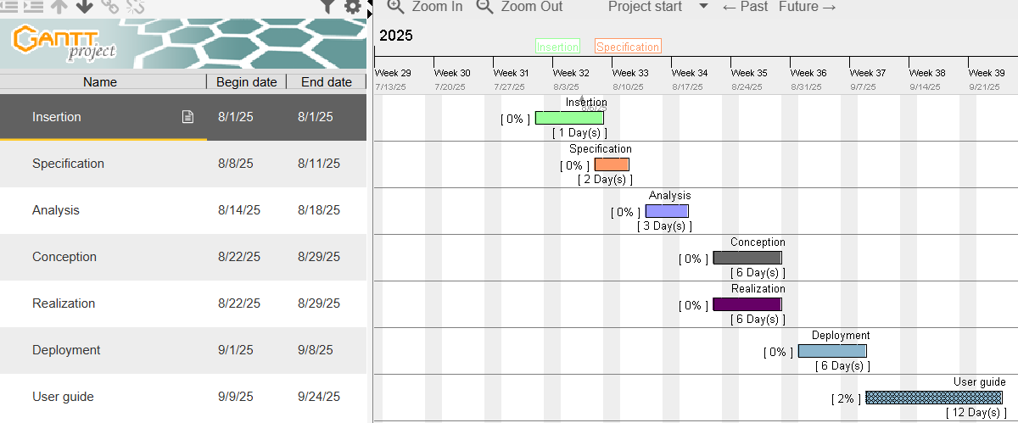
\

CONSTRAINTS

Technical constraint
For the development of our system, we have sufficiently robust tools to guarantee a minimum of security, extensibility and excellent scalability. Moreover, the programming phase will have to follow all the technical standards for a better performance in a reduced execution time, this is why the choice of the development technologies is crucial.

Time Constraint
The project will be realized in 14 weeks starting from the beginning date coupled with many other school projects.

Cost constraint
The realization of our project will require expenditures in human resources, material and software for a total of 10,32 788 FCFA.

LIST OF PARTICIPANTS AND DELIVERABLES

List of participants

Table 9::Project participants
Name Title Role
Mr. LUDOVIC | Telecommunications Engineer | Professional Supervisor
Mr. NDENGUE | Lecture at AICS-Cameroon | Academic Supervisor
Mr. NGANDO ELONG ADRIANO LEFEL | Software Engineering  Student at AICS-Cameroon | Analyst and Developer

Deliverables
In project management, any component materializing the result of a realization.
At the end of this project, we are expected to submit the following;
A complete report containing
- Insertion Book
- Specification Book
- Analysis Book
- Conception Book
- Realization Book
- Software Setup
- User’s guide

CONCLUSION
Having come to the end of our specification book, we recall that for this part of our report, we had set as objectives: to clarify the scope of our project by defining its context and demonstrate its relevance through the justification. We were also to set objectives for our project, express the needs it will respond to, estimate the cost of the project and define a detailed plan we will follow to realize our project. In addition to the objectives set for this section of the report, we saw the list of participant and deliverable for our project. In the time allocated for this section, we were able to meet all the set goals which means we can advance to the next section of our report, the analysis phase. In the analysis phase, we will study the existing system in detail and model our system with a modelling language and process.

BOOK THREE: ANALYSIS PHASE

Preamble

After specification book, we have the Analysis phase which permits us to
represent a detailed analysis of the limitations identified in our context, and our
solution, through a software development process and modelling language.
Content overview

INTRODUCTION
- PRESENTATION OF THE ANALYSIS APPROACH
- MODELLING OF THE PROPOSEDSOLUTION

CONCLUSION

INTRODUCTION
As Engineers our role in the society is problem-solving which is targeted as making life easier for everyone and in order to bring forth a solution, we ought to ask ourselves some questions to know why the problem exist in the first place and how it is being dealt with at the time. Most often we realize that there is an existing system put in place to solve the problem irrespective of its nature, we either need to bring forth a new system or bring improvement to the existing system. No matter which routes we decide to take we need to study and understand the functioning if the system our propose solution to really make a difference. System development can be thought of as having two major components; system analysis and system design. In system analysis, the emphasis is placed on the understanding the details of the existing system, propose a new one and then deciding whether the proposed system is desirable or not, or whether the existing system needs improvements

PRESENTATION OF THE ANALYSIS METHOD
We studied multiple analysis methods in order to get a better orientation on which one to choose for our system. Below are some analysis methods we studied;

A. SOME ANALYSIS METHODS/APPROACH
- MERISE : MERISE stands for “Méthode d’Etude et de Réalisation Informatique pour des Systèmes d’Entreprise”. Although it is prescriptive to some extent, MERISE permits the participation of end users and senior management as well as data processing professionals in its decision cycle. MERISE is a method for designing, developing and carrying out IT projects. The goal of this method is to achieve the design of an information system. The MERISE method is based on the separation of data and processing to be carried out in several conceptual and physical models. The essentials of the approach lie in its three cycles: the decision cycle, the life cycle and the abstraction cycle, which cover data and process elements equally. The separation of data and processing ensures longevity in model. Indeed, the arrangement of data does not have to be often overhauled, while treatments are more frequently.
- SCRUM: In the agile Scrum world, instead of providing complete, detailed descriptions of how everything is to be done on a project, much of it is left up to the Scrum software development team. This is because the team will know best how to solve the problem they are presented. This is why in Scrum development, for example, a sprint planning meeting is described in terms of the desired outcome (a commitment to a set of features to be developed in the next sprint) instead of a set of Entry criteria, Task definitions, Validation criteria, exit criteria (ETVX) and so on, as would be provided in most methodologies. Agile scrum methodology is a project management system that relies on incremental development. Each iteration consists of two- to four- week sprints, where each sprint's goal is to build the most important features first and come out with a potentially deliverable product. More features are built into the product in subsequent sprints and are adjusted based on stakeholder and customer feedback between sprints.

- UP: The UP is an abbreviation of Unified Process. It is an iterative and incremental software development methodology. The Unified Process is an iterative, architecture centric software development process driven by use cases and geared towards reducing risk. It is a process pattern that can be adapted to a wide class of software systems, to different areas of application, to different types of businesses, to different skill levels and to different sizes of the business. Different data. It qualifies a process or a procedure that performs a group of operations repeatedly until a well-defined condition is met.

DYNAMIC SYSTEM DEVELOPMENT METHOD(DSDM):
It is an organized, common-sense process focused on delivering business solutions quickly and efficiently rather than just team creativity. It is similar in ways to SCRUM and XP, but it has its best uses where the time requirement is fixed.

CHOICE OF THE ANALYSIS APPROACH

Two Track Unified Process (2TUP)
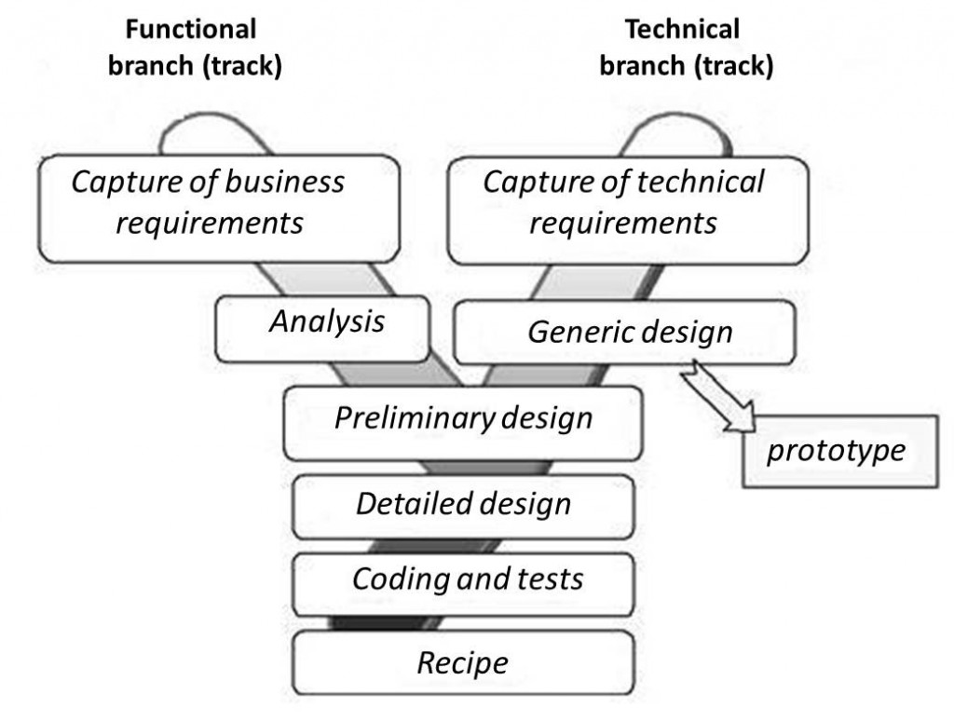
2TUP is a unified process, that is, it is a software development process built on UML. The 2TUP brings an answer to the constraint of continual changes imposed by the information system of an enterprise. In this sense, it enforces the control on the capacity of evolution and correction of the system. The 2TUP offers a Y-shaped process that divides the technical aspects giving two branches, namely the functional branch and the technical branch, which justifies why it is a two-track process. These two branches finally merge into the realization branch for the implementation of the system. The figure below illustrates the 2TUP:

Figure 3: 2TUP Diagram (Source: www.memoireonline.com)

a) Functional Branch
The functional branch captures the functional needs of the system and analyse them. This phase specifies the elements of the preliminary study and does not depend on technology used to build the system.

b) The Technical Branch
The technical branch enumerates the technical needs and proposes a generic design validated by a prototype. The technical needs here include the tools, materials and technologies that will be used along with the different constraints such as worst-case scenario and integration with the existing controls.

c) Realization Branch
The realization track supports the following:
- The preliminary conception: This is the most sensitive step of the 2TUP. This is the meeting point between the functional and technical branches. It ends when the deployment model, the operating model, the logical model, interfaces and software configuration model are defined;
- The detail conception: This is the detailed design of each feature of the system;
- Coding and testing: This are the programming phase of the designed features, alongside testing of the coded features;
- The Recipe: This is the validation phase of the functions of the system developed

Modelling with UML 2.5
The 2TUP and UML work in close collaboration. Having already discuss briefly on 2TUP, UML being its foundation is not to be taken lightly. UML stands for Unified Modelling Language. It can be used to model a system independent of a platform language. UML is a graphical language for visualizing, specifying, constructing, and documenting information about software-intensive systems, some of which are object oriented. UML gives a standard way to write a system model, covering conceptual ideas, hence it is a privilege vector of communication between members of a team. Before proceeding, here are some key terms to understand:
Model: A model is an idealized, abstract and simplified representation of a real-world object or a simplified simulation of an entity.
Why is UML Unified: UML is said to be unified because it is a combination of three modelling approaches namely:
- Object Modelling Technique (OMT) which provides a graphical representation of the static, dynamic and functional aspects of a system;
- Booch approach which was excellent for design and implementation. It introduces the notion of packages;
- OOSE (Object-Oriented Software Engineering) approach which focuses on design base on the user’s needs.
How is UML a language: The UML notations are a standard are widely in the professional milieu. The notations are a must, however the usage these notations in a software development approach are not, hence it is just a guide line.

UML 2.5 defines 14 diagrams that are classified into two main categories: Structural and Behavioural diagrams

a) Structural diagrams:
Structural diagrams show the static structure of the system and its parts on different abstraction and implementation levels and how they are related to each other. The elements in a structure diagram represent the meaningful concepts of a system, and may include abstract, real world and implementation concepts. In UML 2.5 there are seven types of structural diagrams as follows:
- Class diagram;
- Component diagram;
- Deployment diagram;
- Object diagram;
- Package diagram;
- Composite structure diagram;
- Profile diagram;

b) Behavioural diagrams
Behavioural diagrams show the dynamic behaviour of the objects in a system from the beginning of a task to its completion. Below are the behavioural diagrams in UML 2.5:
- Use case diagram;
- Activity diagram;
- State Machine diagram;
- Sequence diagram;
- Communication diagram;
- Interaction Overview diagram;
- Timing diagram

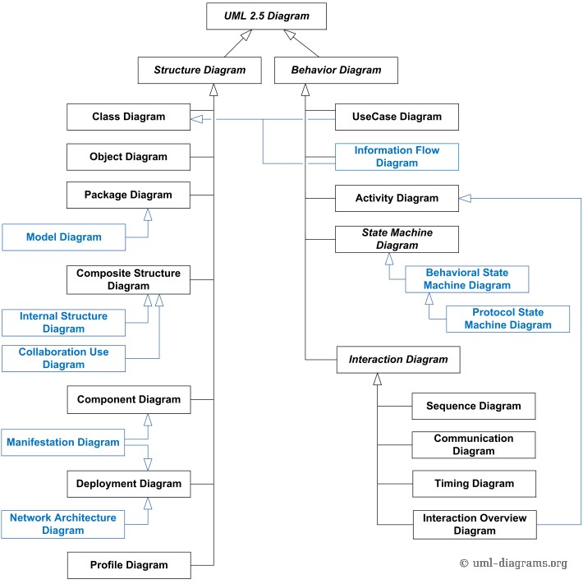
Figure 4: UML 2.5 Diagrams Overview (source: http://www.uml-diagrams.)

MODELING OF THE PROPOSED SOLUTION

Use Case Diagram

Definition
Use case diagram is a graphic depiction of the interactions among the elements of a system. A use case is a methodology used in system analysis to identify, clarify, and organize system requirements.

Formalism
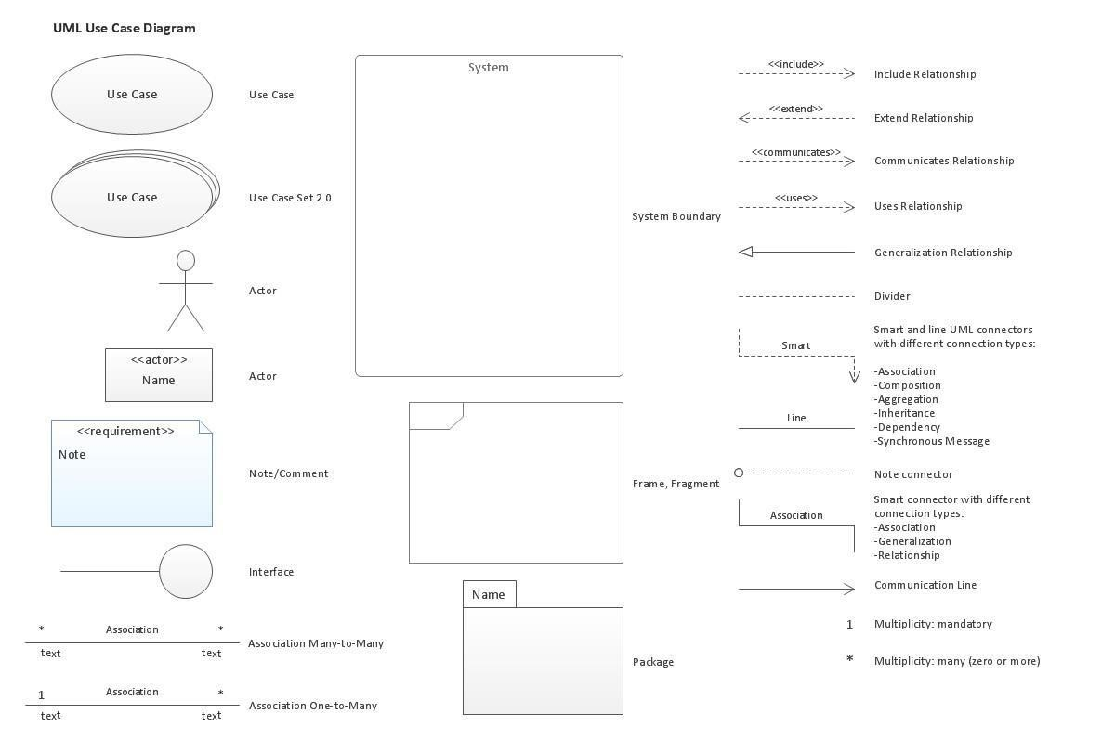
Figure 5: formalism of a Use Case diagram

The components of a use case diagram

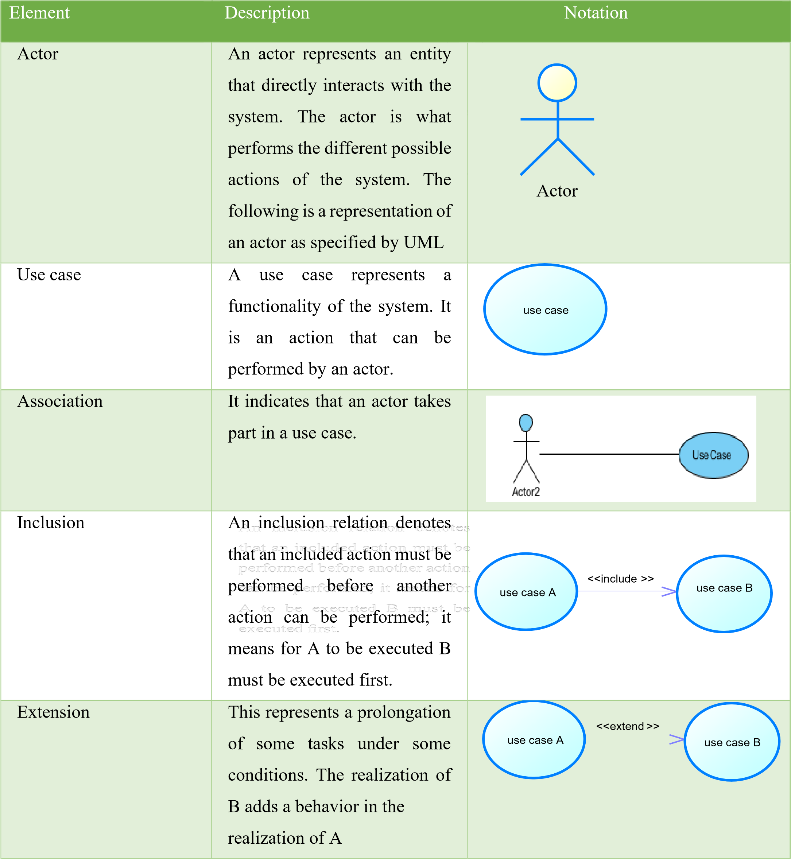
Table 10:Use case diagram components

Generalization | This show that an actor or use case is a kind of another. Abstract or concrete actors can be defined and later specialized using  generalization relationship | 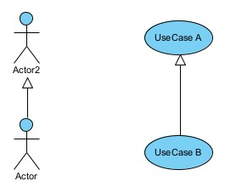
System | It is a container of use cases which interact with external actors | 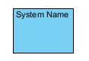

List of actors:
- Vendors: Manages car listings, test drives and view analytics reports.
- Client / Buyer: Authenticated users who can browse, save, share, calculate EMI, book test drives, and access personalized AI recommendations.
- Visitor: Unregistered users who can browse inventory and use search features but must register to interact fully with the platform.
- Admin: manage users account.

General use case

Manage car specific use case

Make payment specific use case

Textual description of use cases
UML allows the execution of a use case to be described in a textual way, in a form called nominal scenario. A nominal scenario describes in more detail the execution of a use case by an actor until it is successfully completed.

Table 11: Formalism of Textual Description
NAME OF THE USE CASE
Actors | Users
Objective | Aim of the use case
Presuppose | Set of actions that must be completed before the launching of the use case
Post condition | Set of actions that must be completed before the launching of the use case
Triggers | Element that triggers the use case
Principal Scenario | Description of the principal scenario
Alternative Scenario | Descriptions of alternative scenarios (where the nominal scenario is a failure)
Post condition | Set of mechanism that can lead to the end of the use case

Title | Authenticate
Summary | This use case describes the process connect to the system
Actors | Users
Stakeholder | VEHIQL Directors
Version | 1.0
Precondition (s) | - The app is launched.  - The actor has an active account on the platform.
Triggers | The user clicks on skip button
Nominal Scenarios | - The system displays the login form.  - The actor fills and submits the form.  - The system verifies conformity of the form fields  - The system sends the data to the dbms.  - The dbms returns result of the query.  - The system verifies the dbms result.  - The system displays a success message to the actor.
Alternative Scenarios | - At step 3 of the nominal scenario, the user enters mismatched or missing information.  - The system displays an error message then returns to step 2 of the nominal scenario.  - At step 6 of the nominal scenario, the dbms result is not valid.  - The system displays an error message then returns to step 2 of the nominal scenario.
Exception scenarios | - The user enters incorrect credentials 3 time, the form submission is  block for 1 min
Postcondition of success | The user has access to his/her dashboard

TEXTUAL DESCRIPTION OF AUTHENTICATION

Table 12:authentication textual description

TEXTUAL DESCRIPTION OF ADD CAR

Table 13:add car textual description
Title | Add car
Summary | This use case describes the process of adding a car in the system
Actors | vendor
Stakeholder | VEHIQL Directors
Version | 1.0
Preconditions | - The actor is logged into the system.
Triggers | The user clicks the "add car" button.
Nominal Scenarios | - The system displays add car form.  - The actor fill and submits the form.  - The system checks form conformity.  - The system send query to the dbms to store the car details.  - The dbms returns result of the query.  - The system verifies the dbms result.  - The system displays a success message to the actor.
Alternative Scenarios | - At step 3 of nominal scenario, if the vendor enter mismatched or missing information The system displays an error message and return to step 2 of the nominal scenario.  - At step 6 of the nominal scenario, the dbms result is not valid. The system displays an error message then returns to step 2 of the nominal scenario.
Postconditions of  success | The car is added successfully.
Postconditions of  failure | The car is not added.
Non-functional  requirement | There must be a good network connectivity

TEXTUAL DESCRIPTION OF BOOK TEST DRIVE

Table 14:book test-drive textual description
Title | Book test drive
Summary | This use case describes the process of booking a test drive.
Actors | client
Stakeholder | VEHIQL Directors
Version | 1.0
Preconditions | - The actor is logged into the system.
Triggers | The user clicks the "add car" button.
Nominal Scenarios | - The system displays book test drive form.  - The actor fill and submits the form.  - The system checks form conformity.  - The system send query to the dbms to store the car details.  - The dbms returns result of the query.  - The system verifies the dbms result.  - The system displays a success message to the actor.
Alternative Scenarios | - At step 3 of nominal scenario, if the client enters mismatched or missing information The system displays an error message and return to step 2 of the nominal scenario.  - At step 6 of the nominal scenario, the dbms result is not valid. The system displays an error message then returns to step 2 of the nominal scenario.
Postconditions of  success | The test drive has been booked successfully.
Postconditions of  failure | The test drive hasn’t been booked.
Non-functional  requirement | There must be a good network connectivity

Sequence Diagram

Definition
A sequence diagram is a diagram that shows the interaction details, and how operations are carried out. Sequence diagrams focus on the message interchange between a number of lifelines.

Formalism
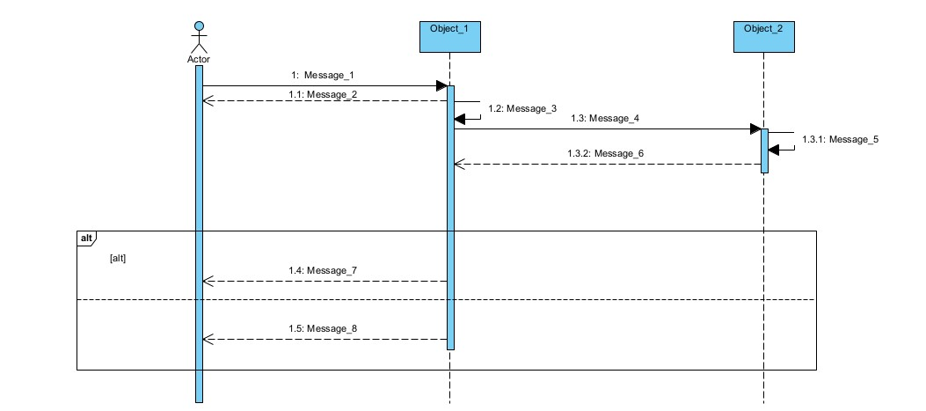
[
OK
]

[
NOT
Figure 6: Sequence Diagram Formalism

The components of a sequence diagram
Table 15:Component of a Sequence Diagram
Element Representation Description
Lifeline | 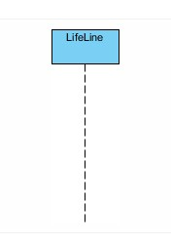 | It represents the presence of an object over time in the execution of a modelled function.
Activation | 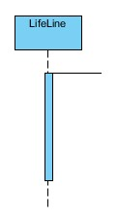 | It is used to represent a period during which an objective is active when a modelled use case is running
Message | 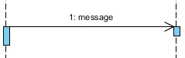  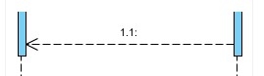 | Message are arrows that represent  communication between objects: Synchronous message: Message completed with feedback. Asynchronous message: Message complete without waiting for feedback.
Combined fragment | 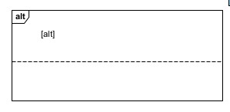 | Used to group messages together to show conditional flow in a sequence diagram

Create Account/ Register sequence diagram

Authenticate sequence diagram

Manage car sequence diagram

Activity Diagram

Definition
An activity diagram is a graphical representation of workflows that show the step needed in the realization of a process showing the details from start point to an end point through all the decision and actions that can possibly be performed. Activity diagrams are intended to model both the computational and organizational process. They show the overall flow, which is drawn from one operation to another. This flow can be sequential, branched or concurrent. Below is the activity diagram formalism.

Formalism:
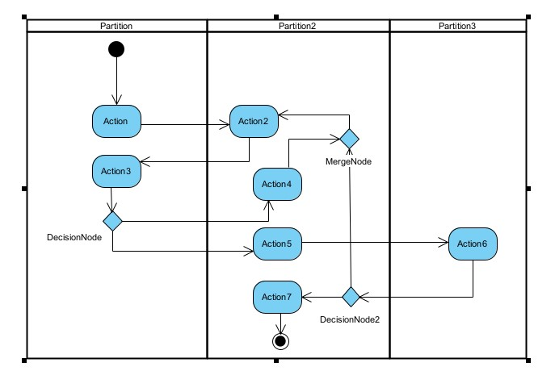 Figure 7: Activity Diagram Formalism

The components of an activity diagram

Table 16: Component of an Activity Diagram
ELEMENT DESCRIPTION |  | NOTATION
Activity | An activity is shown as a rounded-concerned rectangle enclosing all the actions, control flow and all the element that make up the activity. | 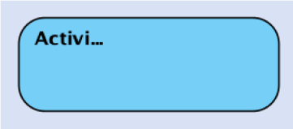
Action | It represents a single step within an activity. Actions are generally denoted by rounded cornered rectangles | 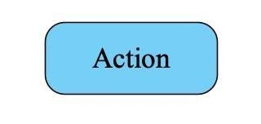
Transition (Control Flow) | Control flows show the flow of control from one action to the next. It’s represented by a line with an arrow head | 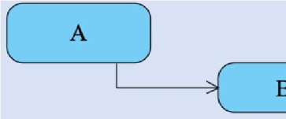
An Initial or Start node | It is depicted by a large black spot | 
Final Nodes | They are diamond shaped having control flows with guard conditions | 
Object Node | An object node is an activity node that indicate an instance of a particular classifier or a particular point in the activity | 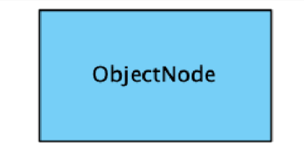
Swim Lanes | This is where we place activities. Items are listed inside it. | 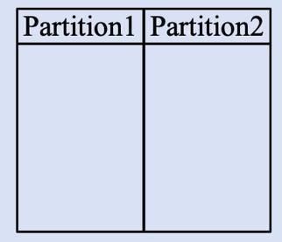
Flow Final node | This indicates the end of a flow | 

Create Account activity diagram

Login activity diagram:

Manage car activity diagram:

CONCLUSION
The Analysis document has enabled us to sort out the problem at hand, and then proposed a solution that will lead to the realization of this Application. From here we will proceed to the conception phase where we shall see a detailed conception of the system.

BOOK FOUR: CONCEPTION PHASE

Preamble
The conception phase is part of the document that shows the link between the analysis and the realization phase. It is a continuation of the analysis phase which represents the technical aspects used in modelling our system.
Content

INTRODUCTION
- TECHNICAL BRANCH
- CAPTURE TECHNICAL NEEDS
- RELATED UML DIAGRAMS
CONCLUSION

INTRODUCTION
The conception phase consists of defining the necessary components to the construction for the technical architecture. This conception is completely independent of the functional aspects. In this phase, we are going to see the technical branch of 2TUP which consist of technical needs and capture of the various UML diagrams that are going to permit us to model our system.

I. TECHNICAL BRANCH
Generic Design.

Hardware Diagram of the System
The hardware diagram shows in details how the application components of our system are deployed through the adequate computer network. Below is the hardware diagram of our system


User 1

User
2

User
3

Main server

Database

server

Admin portal

Administrator

Internal domain

Firewall

External domain

:

Figure 8:Hardware Diagram of the system

CAPTURE OF TECHNICAL BRANCH

Physical Architecture of the System
The physical architecture diagram shows the machines in which different application components of our system will be installed. We will use a n-tier architecture
The tiers of our system include:
- The client tier, represents the user interface,
- The application tier, which runs on a Java web server;
- The data tier, that runs on a database server.
- The Gemini API

Logical Architecture of the System
To avoid a lack of maintainability, testability and scalability, which are drawbacks of the traditional approach of programming which works on Input-Processes-Output, we opted for the MVC architecture of our application. MVC is an Acronym for Model View and Controller. The MVC architecture is a design pattern that is used in software engineering to separate the application’s logic from the user interface. As the name implies, the MVC is described in three layers, namely:
- The Model (business logic and access to data);
- The View (user interface);
- The Controller (request handler) performs the action of invoking the Model and sending data to the View.
The MVC layers are independent from one another. A change in the content of one will have no effect on the others. This is a great advantage in that it facilitates maintenance and follow up of the software. Below are derails concerning the layers:
- Model: Model objects are the parts of the application that implement the logic for the application’s data land registry. Model objects retrieves and store model state in a database. The model itself can be sub divided into many levels but this decomposition is not shown at the MVC level
- View: The view has components that display the application’s user interface (UI).
It is the presentation layer used to display the Model data fetched by the controller.
- Controller: This layer acts as an interface between View and Model. It receives requests from the View layer and processes them, including the necessary validations. The request is further sent back to the Controller and then displayed on the View.

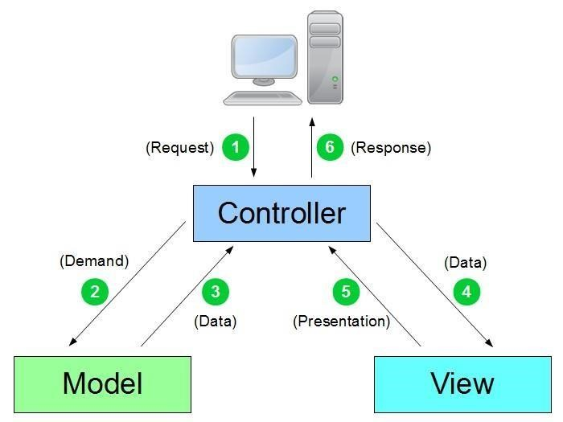
Figure 9: MVC pattern diagram

Advantages of MVC Design Pattern
- Simultaneous development: MVC architecture makes it possible for multiple developers to work simultaneously on the model, controller and views.
- High cohesion: MVC enables logical grouping of related actions on a controller together. The views for a specific model are also grouped together.
- Low coupling: The very nature of the MVC frame work is such that there is low coupling among models, views and controllers.
- Ease of modification: Because of the separation of responsibilities, future development or modification is easier, that is scalability of the product is increased.
- Multiple views for a model: Models can have multiple views.

III. RELATED UML DIAGRAMS

A. Class Diagram

a) Definition
In UML, a class diagram is a type of static structure diagram that describe the structure of a system by showing the system’s classes, their attributes, their methods or operations and their relationship among objects. Classes are represented with boxes that contain three compartments:
- The top compartment containing the class name;
- The middle compartment containing the attributes of the class;
The button compartment containing the operations the class can execute.

b) Formalism
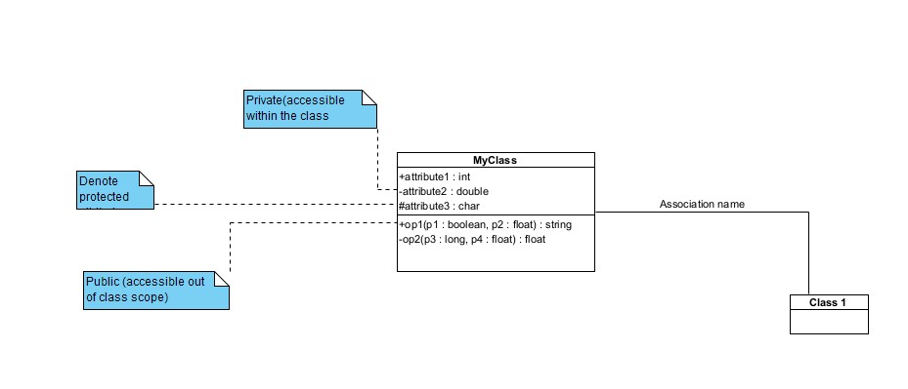
Figure 10: Class Diagram Formalism

The components of a class diagram

Table 17:Component of a Class diagram
Element Representation Description
Inheritance or  Generalization | 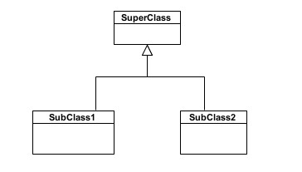 | A generalization is used to indicate inheritance. It shows a parent class generalizing a child class
Association | 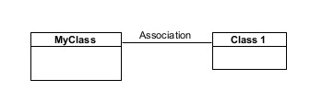 | It is the general relationship type between elements. This connector may include named roles at each end, cardinality, direction and attributes.
Aggregation | 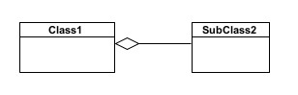 | If the parent of aggregate is deleted, Usually the children are not deleted.
Composition | 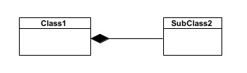 | If the Parent of a composite is deleted, usually, all of its parts are deleted within it.
Class | 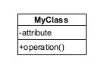 | A class is an element that defines the attributes and behaviour that an object is able to generate.
Dependency | 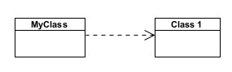 | Exists  between two classes if changes in the definition of one may cause changes to the other, but not the other way around.

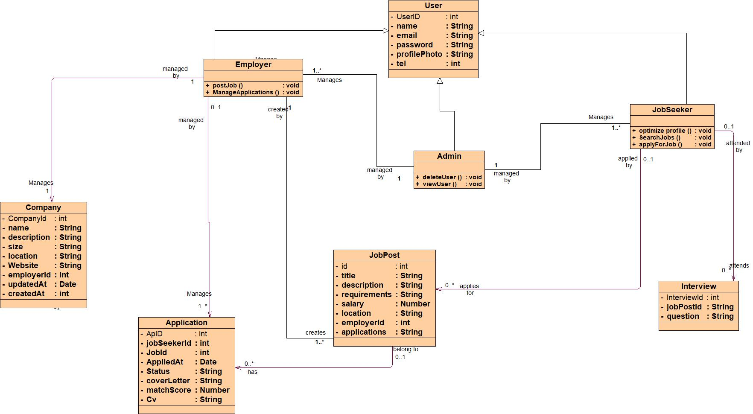
System Class Diagram

Figure 11: System class Diagram

B. State Machine Diagram

a) Definition
A state machine diagram describes the behaviour of a single object in response to a series of events in a system. Also known as the state chart diagram, it models the dynamic flow of control from the state of a particular object within a system.

b)Formalism

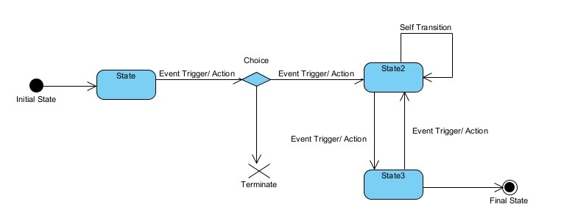

:

State Machine Diagram

Figure 12:Formalism of a state machine diagram

The Components of State Machine Diagram

Table 18:Components of a State Machine diagram
ELEMENT | DESCRIPTION | NOTATION
States | A state is denoted by a rounded cornered rectangle with the name of the state written inside it. | 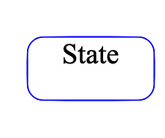
Initiates states | The initial states is denoted by a field circle and may be labelled with name. | 
Transitions | Transitions from one state to the next are denoted by lines with arrow heads. A transition may have a trigger, a guard and an effect. | 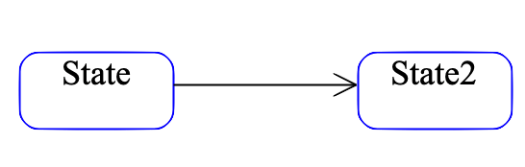
Junction | Junction vertices are semantic free vertices that are used to chain together multiple transitions. They are used to construct compound transition paths between states | 
Final states | The final state is denoted by a circle with a dot inside | 

System State Machine Diagram
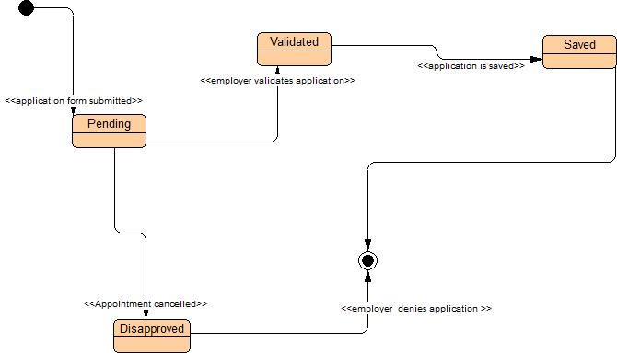

Figure 13: Post Job State machine diagram

C. Package Diagram

a) Definition
Package diagrams serve the purpose of reflecting the organization of package and their elements. When used to represent class element, package diagram provides a visualization of the namespaces. The most common use for package diagram is to organize use case diagram and class diagram although the use of package diagram is not limited to these elements.

b) Formalism
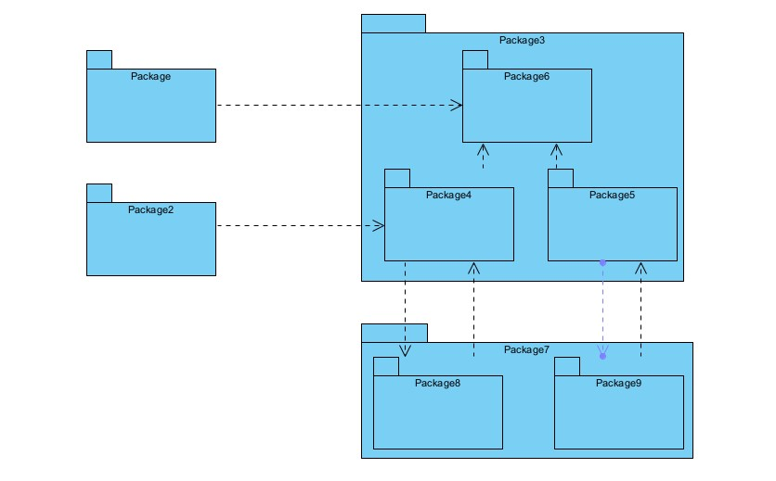
Figure 14: Formalism Package Diagram

c)The Components of a State Machine Diagram

Table 19:Package Diagram Formalism
Name Representation Description
Package | 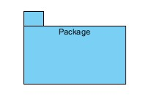 | A package is a namespace used to group together elements that are semantically related and might change  together. It is a general-  purpose mechanism to organize elements into groups to provide a better structure for system model
Package  Merge | 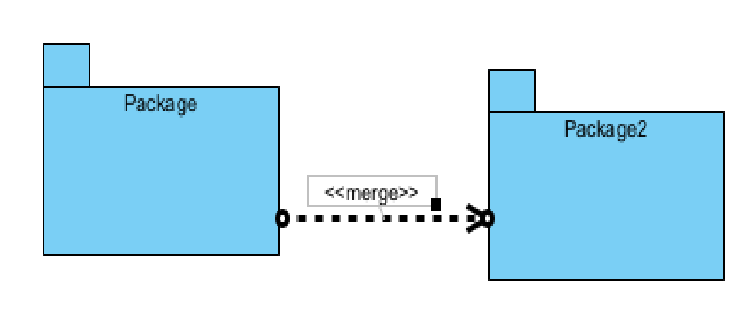 | It is a direct relationship between two packages that indicates that the content of the target (merged package) is combined into the source (receiving/merging package).
Package  Import | 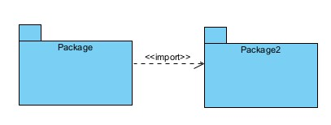 | This is a direct relationship between an importing namespace and imported package, that allows the use of unqualified names to refer to the package members from other namespaces.
Package access | 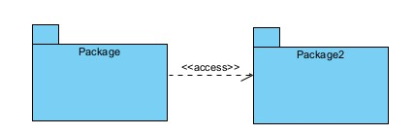 | It is a direct relationship used to show that a UML element or a set of elements require(s) or depend(s) on another model element for  implementation

Package Diagram

Definition

Formalism

The Components of a Package Diagram

The System Package Diagram

E. OBJECT DIAGRAM

a) Definition
An object diagram is an instance of a class in a particular moment in runtime that can have its own state and data values. It shows a snapshot of the detailed state of the system at a point in time, thus an object diagram encompasses objects and their relationships whish may be considered a special case of a class diagram.

b) Formalism
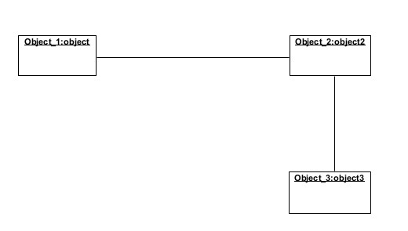
Figure 15: Object diagram formalism

c)The Components of an Object Diagram

Table 20:Components of an Object Diagram
Element | Representation | Description
Object | 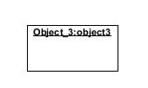 | An object is an instance of a  class
Link | 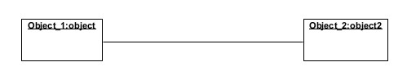 | Links between  objects  correspond to  associations  between the  object’s classes Thus, a link is an instance of an association.

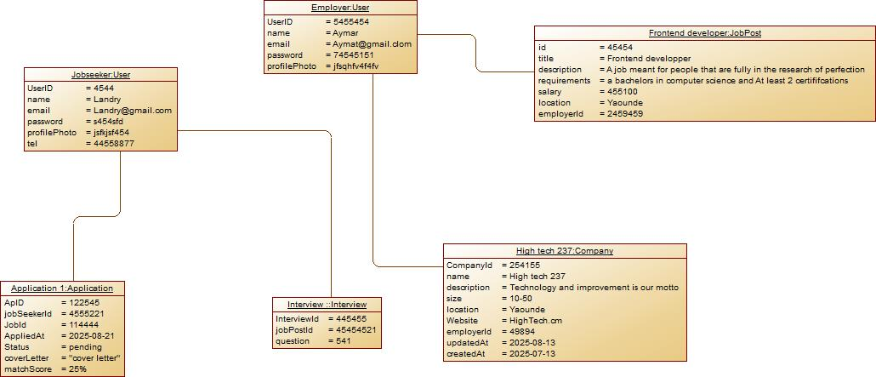
d)System object diagram

Figure 28:system Object diagram

CONCLUSION
From the conception document, we can now conceive in detail the proposed solution on the structural plan, organizational, materialization of various models which are the use case to have a view of how the realization of our solution to the problem posed will be implemented. Hence the next step will be essentially be consecrated to the realization of the solution.

BOOK FIVE: THE REALIZATION PHASE

Preamble
The realization phase contains the fact that are strongly related to the analysis phase and aim at the physical implementation of the software
Content

INTRODUCTION
- COMPONENT DIAGRAM
- DEPLOYEMENT DIAGRAM
- CHOICES OF TECHNOLOGIES

CONCLUSION

Component Diagram

Definition
A component diagram represents modular aspect of an object-orientated system that encapsulate their content and whose manifestation is replaceable within their environment. The modular aspect includes: run-time, executable and source code components.

Formalism
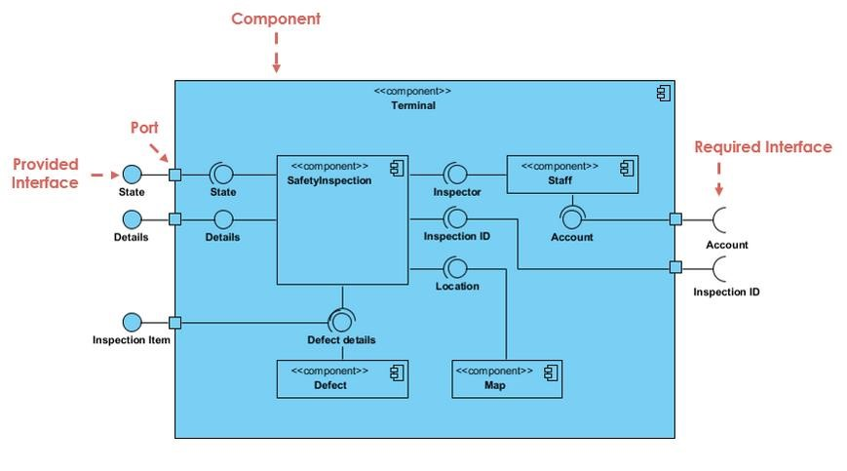
Figure 16:Component diagram formalism (https://www.visual-paradigm.com/guide/uml-unified-modeling-language/what-iscomponent-diagram)

The components of a component diagram

Table 21: Formalism of a component Diagram
Name | Representation | Description
A component | 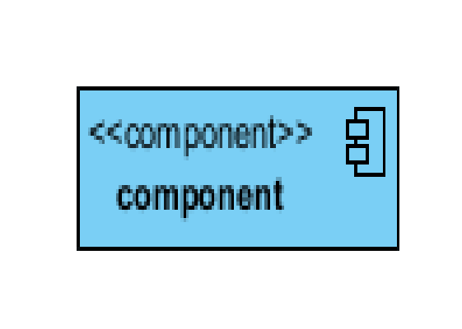 | A component is an abstract logical unit block of a system. It is represented as a rectangle with a smaller rectangle in the upper right corner with tabs, or the word written above the name of the  component
Dependency | 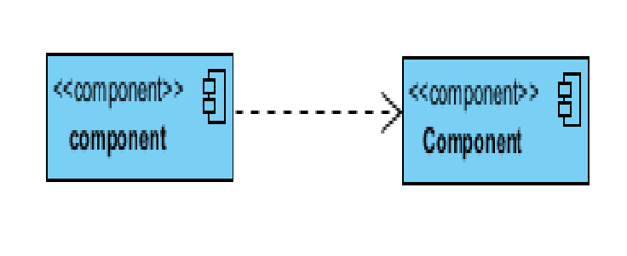 | Dependency is a directed relationship which is used to show that some component or set of components depend on other component elements for specification and implementation. It is represented with dashed arrows
Interface | 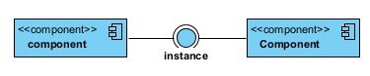 | An interface (small circle or semi-circle on a sick) describes a group of operation required or provided by components

The System Component Diagram
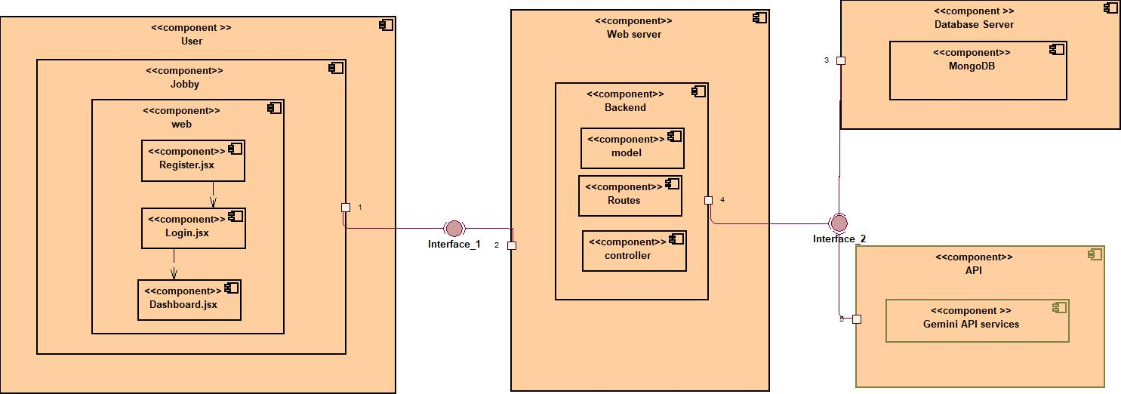

Figure 17:Component Diagram

Deployment Diagram

Definition
The deployment diagram is a structural diagram that shows the architecture of a system as distribution of software artefacts to deployment targets. It involves modelling the hardware configuration together with the software component that live on them.

Formalism
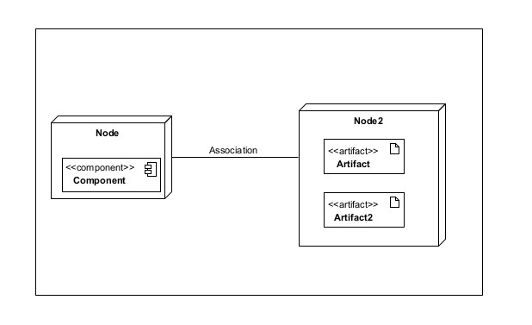
Figure 18: Formalism Deployment diagram

The Components of a Deployment Diagram

Table 22: Component of a Deployment Diagram
Elements | Representation | Description
Node | 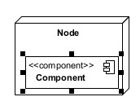 | A node is either a hardware or a software
Artifact | 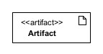 | An artifact is a product of a software development process or the operation of a system.
Component | 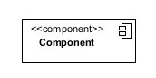 | It represents a modular part of a system that encapsulates its content and whose manifestation is replaceable within its environment
Association |  | An association represents a communication path between nodes.

The System Deployment Diagram

Choices Of Technologies

Material Resources

Table 23: Material resources
HARDWARE RESOURCES
- HP Computer, Intel core i3 1TB , RAM 20GO

- WIFI HOME BOX

Software Resources

Table 24: Software resources
SOFTWARE NAME | VERSION | USAGE | LOGO
OS window 10 | 18.32 | The operating system we worked on is Windows 10 | 
Visual paradigm | 16,5 | The software engineering workshop used for solution modeling is called "Enterprise Architect." We utilized this tool to create various diagrams for our system modeling.
Visuel studio code | 1.93.1. | The text editor used to enter the lines of code that will be interpreted by the browser is called a "code editor." | 

3.Language Used
- JavaScript (JS) was indeed developed by a team at Netscape Navigator, led by Brendan Eich. Created in 1995, JavaScript is a scripting language that is embedded within an HTML document. Historically, it is the first scripting language for the web. Numerous frameworks are based on JavaScript, both for web and mobile development.

Figure 19: JavaScript logo
- Reactjs: A JavaScript framework for building the web app,


Figure 20 :React logo
- Nextjs: A JavaScript framework for building the web app, it adds powerful features on top of react.



Figure 21 :next logo
- CSS (Tailwind CSS): Used for styling the app's components via the twrnc (Tailwind React Native Class names) library.

Figure 22 :CSS logo

- Node.js: JavaScript runtime used on the backend for handling server-side operations.

Figure 23 Nodejs logo

BOOK SIX: TEST OF FUNTIONALITIES

Preamble
In this phase, we will present the various functionalities of VEHIQL, our AI-powered car marketplace platform. This chapter focuses on demonstrating the core features of the application, explaining how they benefit the users, and how they support the platform’s intended purpose of providing a smooth, intelligent, and secure car trading experience.

INTRODUCTION
The test of functionalities phase allows us to evaluate the performance and usability of our solution, whether web-based or mobile. It highlights the various functionalities or modules present in the application, detailing how each contributes to the user experience. In this chapter, we will explore the essential features of VEHIQL, emphasizing their advantages for the users.

I. APPLICATION FUNCTIONALITIES
1. Authentication
This functionality allows all user roles (visitors, clients, vendors, and administrators) to securely access the platform. Visitors can sign up to become clients, while vendors and administrators log in with secure credentials to access their dashboards and system features.
2. Car Listing and Discovery
Users can browse through a wide range of verified car listings. The platform provides advanced search filters (make, model, price, body type, etc.) and an AI-powered image search, allowing users to find vehicles quickly and accurately.
3. Profile and Account Management
Clients, vendors, and administrators can manage their personal profiles by updating details such as name, contact information, and account settings. This ensures accurate user data and enhances personalization.
4. Car Management (Vendors)
Vendors can create and manage car listings, either manually or through AI-assisted image uploads with automatic data extraction. They can update details, change car status (available, sold, pending), feature vehicles on the homepage, or delete listings when necessary.
5. Client-Side Actions
- Clients (car buyers) can interact with car listings in multiple ways:
- Save favorite cars for later.
- Share listings externally via social media or links.
- Perform EMI calculations to estimate monthly payments.
- Book test drives with real-time dealership availability.
- Request additional information from vendors or administrators.
6. Test Drive Management
This functionality allows clients to schedule and manage test drives, while vendors can view, confirm, cancel, or complete booking requests. This ensures smooth coordination between buyers and sellers.
7. Notifications and Alerts
Users receive important notifications, including test drive confirmations, status updates, and system alerts. This keeps users engaged and informed about their activities on the platform.
8. Reporting and Analytics (Vendors)
Vendors can access analytics dashboards to track inventory performance, user inquiries, and booking statistics. Administrators can generate system-wide reports to monitor platform usage, ensure compliance, and support strategic decisions.

CONCLUSION
Having put in place the platform, it was not sufficient for we had to produce a manual that will help its various users. That is why we presented the different tools to be installed and how they are to be installed in order to run this application without any problem and how the users will use this platform once the environment is set up.

BOOK SEVEN: USER GUIDE

Preamble
This phase actually aims at show the installation process of the application and how it functions.
Content
INTRODUCTION
- INSTALLATION GUIDE
- USER INTERFACE GUIDE
CONCLUSION

INTRODUCTION
This is the final phase of our report. In this section, the requirements for the AI Car Marketplace system will be outlined, followed by a detailed installation process, and instructions on how to access the system and its features. The information will be presented step-by-step to facilitate easy setup for first-time users. Each step in the processes will be paired with explanations for clarity. Afterward, a walkthrough of the application screens will showcase the user interface and highlight key functionalities.

INSTALLATION OF THE APPLICATION
      - System Requirements
Table 25:system requirements for installation
Component | Requirement
OS | Ubuntu 22.04 LTS / Windows (WSL2)
CPU | 4+ cores (8+ recommended for AI-related tasks)
RAM | 8GB (16GB recommended for AI workloads)
Storage | 50GB+ SSD recommended
Network | Ports 80, 443, 3000, 5000 open

2. Backend Setup

Steps:
1. Clone the GitHub repository:
git clone https://github.com/piyush-eon/ai-car-marketplace.git
cd ai-car-marketplace
2. Install dependencies:
npm install
3. Configure environment variables by creating a `.env` file with the following keys:
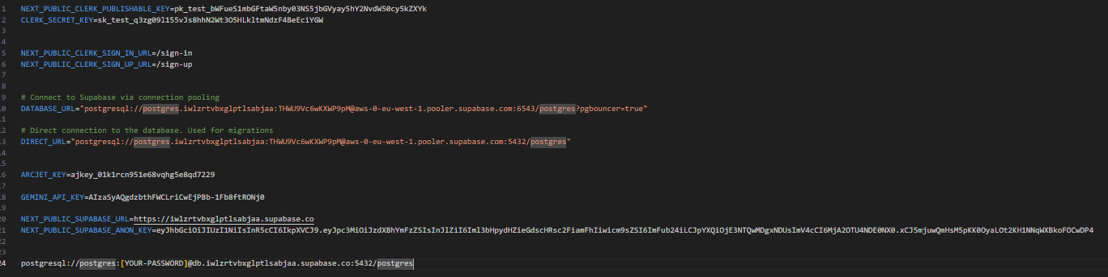

4. Start the backend server (Next.js API routes with Supabase backend):
npm run dev
3. Frontend Setup
Steps:
1. Navigate to the frontend directory (if applicable; in this project frontend is integrated with Next.js):
cd ai-car-marketplace
2. Install dependencies:
npm install
3. Configure `.env` file with the keys as mentioned above.

4. Build and run the frontend with Next.js:
npm run build
npm start
Or for development:
npm run dev
4. AI Modules
Gemini AI API Integration
- The application uses the Gemini API for AI-powered car search and image recognition. Ensure the GEMINI_API_KEY is properly set in the .env file.
- The AI is accessed through API calls integrated within the app; no separate installation needed.
5. Authentication
- The app uses Clerk for authentication services. Ensure Clerk API keys are configured in the environment.
- This provides user sign-in/sign-up, session management, and protected routes for admin and users.

6. Security and Rate Limiting
- Arcjet is employed for rate limiting and bot protection for API endpoints.
- The ARCJET_KEY must be configured in the .env file for this feature to function.

7. Verification
Table 26:system verification
Service | Test Command / Verification Method | Expected Output
Backend | Access API routes via `http://localhost:3000/api` | API responses without error|
Frontend | Open `http://localhost:3000` | Application loads login page
Gemini AI API | Verify API key is valid by running AI-powered search | Relevant search results
Clerk Auth | Test user sign-up and sign-in flows | User session created
Arcjet | Confirm rate limiting on API with multiple requests | Requests get limited after threshold

8. Troubleshooting
Common Issues:
- Backend or Frontend Not Starting:
Check environment variables and dependency installations.
- Gemini AI Search Not Working:
Verify the API key is valid and network access is available.
- Authentication Issues:
Ensure Clerk keys are correctly set and redirect URLs match.
- Port Conflicts:
Verify no other services are occupying ports 3000 (frontend) or the configured API ports.

APPLICATION WALKTHROUGH

Home and Search Interface
- Users can perform AI-powered car searches by uploading a car image or using advanced text filters such as make, model, price range, and body type.
- The search uses the Gemini AI API to find similar vehicles.
Car Details Page
- Displays comprehensive specifications of selected cars.
- Includes high-resolution image galleries and an EMI calculator to assist users in financial planning.
Test Drive Booking
- Users can book test drives with real-time dealership slot availability.
- Automated booking confirmations are sent after booking.
Vendor Dashboard
- Full car inventory management (add, update, delete cars).
- Test drive scheduling and user management.
- Analytics dashboard for tracking user activity and sales.
- AI-powered extraction of car details from uploaded images to automate data entry.
UI/UX
- Built with Next.js 13 and Shadcn UI using Tailwind CSS for a modern, responsive design.
- Role-based protected routes ensure secure access for users and administrators.
WEB Application
To be able to use VEHIQL web application, just connect to the internet and navigate to the website to either create an account or login.

SHOW CASE

Login page

Registration page

Home page

Admin dashboard

Client dashboard

Book test drive page

CONCLUSION
Having put in place the platform, it was not sufficient for we had to produce a manual that will help its various users. That is why we presented the different tools to be installed and how they are to be installed in order to run this application without any problem and how the users will use this platform once the environment is set up.

PERSPECTIVE
- Payment Portal: Integrate a secure and seamless payment gateway to handle transactions directly within VEHIQL.
- Chat Box / In-App Secure Communication System: Provide a built-in messaging platform that enables direct, secure communication between buyers and sellers. This ensures clear, centralized conversations, minimizes misunderstandings, and builds trust between parties. Based on their skills, experiences, and preferences.
- Administrator dashboard can\ sig
- Digital Contract Management: Store all agreements on blockchain or immutable storage with smart contract triggers.
- Real-time Tracking: Integrate with vehicle tracking systems to monitor car location throughout the financing period. increase the chances of successful placements, benefiting both job seekers and employers.

GENERAL CONCLUSION
The AI Car Marketplace project represents a modern, AI-powered solution for transforming the traditional car buying and selling process. By leveraging Next.js 13 with React 19, Supabase, Prisma, and Clerk authentication, the platform ensures a robust, scalable, and secure foundation. The integration of Gemini AI for image-based car search and automated detail extraction enhances accuracy and efficiency, providing users with an intelligent way to discover vehicles.
Key functionalities such as advanced filtering, EMI calculator, real-time test drive booking, and admin-controlled car inventory management contribute to a seamless experience for both clients and administrators. The system’s responsive UI, built with Tailwind CSS and Shadcn UI, guarantees accessibility across devices, while Arcjet security mechanisms ensure protection against abuse and unauthorized access.
Beyond streamlining transactions, the platform emphasizes user engagement, transparency, and trust by incorporating notifications, analytics, and AI-driven automation. Its modular architecture supports future scalability, allowing for integration of additional features like new payment gateways, expanded AI capabilities, or dealership network growth.
Ultimately, this project stands as a comprehensive digital marketplace that not only addresses the inefficiencies of traditional vehicle trading but also positions ABC Logistics under SOS Telecoms at the forefront of innovation in the automotive market. It demonstrates how AI and modern full-stack development can converge to create a secure, efficient, and user-centric platform that fosters stronger connections between seller and buyers.

BIBLIOGRAPHY
Author not listed. Méthode d’Etude et de Réalisation Informatique pour des Systèmes d’Entreprise (MERISE).
Alistair Cockburn. Agile Software Development: The Cooperative Game. Addison-Wesley, 2nd Edition, 2006.
Schwaber, Ken. Agile Project Management with Scrum. Microsoft Press, 2004.
Ivar Jacobson, Grady Booch, James Rumbaugh. The Unified Software Development Process. Addison-Wesley, 1999.
Fowler, Martin. UML Distilled: A Brief Guide to the Standard Object Modeling Language. Addison-Wesley, 3rd Edition, 2003.

GLOSSARY
- API (Application Programming Interface): A set of protocols and tools that enable the AI Car Marketplace platform to communicate with external services such as Gemini AI (for image recognition), Clerk (for authentication), and Arcjet (for security and rate limiting).
- Backend: The server-side of the marketplace built with Supabase and Prisma ORM, responsible for managing business logic, processing requests, handling authentication, and storing car data, user information, and test drive bookings.
- Database Management System (DBMS): The system (PostgreSQL via Supabase) used to store, retrieve, and manage all marketplace data, including car listings, user profiles, transactions, and test drive schedules.
- Car Listing: An advertisement created by administrators (car sellers) that includes details about a vehicle such as make, model, year, price, images, and specifications.
- Car Search: A feature allowing users to discover vehicles using AI-powered image recognition (Gemini API) or traditional filtering options like make, model, price range, and body type.
- 3-Tier Architecture: The structure of the platform divided into three layers:
  - Presentation Layer (Frontend): Built with Next.js, React, Tailwind CSS, and Shadcn UI, providing the user interface.
  - Application Layer (Backend): Handles business logic, authentication, and AI-powered processing.
  - Data Layer (Database): Stores cars, users, test drives, and transaction records.
- UI (User Interface): The visual design of the platform that allows users to interact with the system, such as car search filters, EMI calculators, booking forms, and admin dashboards.
- UX (User Experience): The overall journey and satisfaction users (visitors, clients, admins) get when browsing cars, booking test drives, or managing listings. It focuses on ease of use, responsiveness, and smooth navigation.
- EMI Calculator (Equated Monthly Installment Calculator): A financial tool within the platform that helps clients estimate monthly payments for car purchases based on price, interest rates, and loan duration.
- Test Drive Booking: A feature allowing clients to schedule car test drives with real-time dealership availability, managed and confirmed by administrators.

WEBOGRAPHY
- "Visual Paradigm UML Guide". Accessed from https://www.visual-paradigm.com/guide. Accessed on: 12/07/2024 at 10:45am

- "UML 2.5 Diagrams Overview". UML Diagrams Website. Accessed from http://www.uml-diagrams.org. Accessed on: 28/07/2024 at 9h30

- Realize Cameroon. Company website and resources. Accessed from www.realize-cm.com. Accessed on: 17/08/2024 at 10h00

- "Expo Documentation for React Native". Expo Official Site. Accessed from https://docs.expo.dev. Accessed on:18/08/2024 at 9h0

- "Scrum Framework Overview". Scrum.org. Accessed from https://www.scrum.org/resources/what-is-scrum. Accessed on: 06/09/2024 at 10h45am

- "Tailwind CSS Documentation". Tailwind CSS Official Site. Accessed from https://tailwindcss.com/docs. Accessed on: 20/09/2024 at 10h:00
.
.

ANNEX

TABLE OF CONTENT

